Building a SharePoint 2010 Virtual Machine

**Overview**: This document provides links to Internet resources and step by step instructions for building a Virtual Machine (VM) sample SharePoint Server 2010 environment. This VM can be used to complete the lab exercises in SharePoint 2010 training courses authored by Critical Path Training, LLC. The VM can also be used for general testing and development with SharePoint 2010.

This setup guide gives you the option of using free trial software or supplying your own product keys. The software products that require product keys include Windows Server 2008 R2, SQL Server 2008 R2 Enterprise, SharePoint Server 2010 and Office 2010. If you plan to use evaluation software to build your VM, there are optional steps for downloading Microsoft’s free trial VM for Windows Server 2008 R2 so you can use that as your starting point. You can alternatively install Windows Server 2008 R2 yourself using your own product key so you do not have to worry about the operating system on the VM expiring after a certain amount of time.

Note that the requirements for building out a SharePoint 2010 development environment are more relaxed and have fewer requirements compared to building out a SharePoint 2010 production environment. Therefore, you should not rely on this document as your only resource when you are installing SharePoint 2010 for production use. The following list of assumptions has been made:

* All software is installed and configured on a single server
* DNS entries are mapped using a HOSTS file
* The server is an Active Directory domain controller
* All SharePoint worker processes will initially be configured to run under a single AD account

In addition to this guide you can check out the Critical Path Training YouTube channel to see videos demonstrating each step in this guide: [**http://www.youtube.com/users/CriticalPathTraining**](http://www.microsoft.com/downloads/details.aspx). The video series is saved in this playlist: [**http://bit.ly/a9Vo68**](http://technet.microsoft.com/en-us/evalcenter/ee390818.aspx).

**Table of Contents**

Section 1: Configure Hyper-V and Create a New Virtual Machine (VM) 3

Section 2: Install and Configure Windows Server 2008 R2 7

Install Active Directory Domain Services 13

Configure Windows Update 16

Section 3: Install SQL Server 2008 R2 Enterprise 17

Section 4: Install and Configure SharePoint Server 2010 25

Post-Installation Configuration of SharePoint Server 2010 31

Create a New Web Application 32

Configure Internet Explorer 8 for Testing 38

Section 5: Install Microsoft Office 2010 Client Applications 40

Install Office 2010 Professional Plus 40

Install SharePoint Designer 2010 41

Install Visio 2010 41

Configure Office 2010 Trust Settings 42

Section 6: Install Visual Studio 2010 43

Appendix A: Download Windows Server 2008 R2 Evaluation VM 48

Appendix B: Create the Sample Adventure Works Databases 52

Appendix C: Install SharePoint Developer Utilities and SDKs 53

Appendix D: Install the Office Web Applications 54

## Section 1: Configure Hyper-V and Create a New Virtual Machine (VM)

*This guide walks you through how to setup a virtual machine using Microsoft’s Hyper-V virtualization product that’s part of Windows Server 2008 & Windows Server 2008 R2. While there are other virtualization products available to developers, this guide only covers Hyper-V. However, most of the steps in this guide can be applied to creating a virtual machine with other virtualization products such as VMWare Workstation or VirtualBox.*

Review to the following video for a walkthrough on the following steps: [**http://bit.ly/cPw8Xv**](http://technet.microsoft.com/en-us/library/cc262485.aspx).

1. Ensure your computer hardware and software meet the following requirements.
   1. Your computer is running a 64-bit installation of Windows Server 2008 R2
   2. Your computer has a connection to the Internet
   3. Your computer has at least 6GB of RAM (8GB+ recommended)
   4. Your computer has at least 80GB of free disk space.
   5. Your computer supports virtualization and has Hyper-V Services enabled.
   6. If you need more information on how to install and configure Hyper-V, you can read more at [http://www.microsoft.com/windowsserver2008/virtualization/install.mspx](http://intranet.wingtip.com) or http://bit.ly/9QGrsW.
2. Launch the Hyper-V Manager from the Windows Start menu.
   1. **Start » Administrative Tools » Hyper-V Manager**. If you are using Hyper-V for the first time there will be no existing VMs in the Virtual machines section.

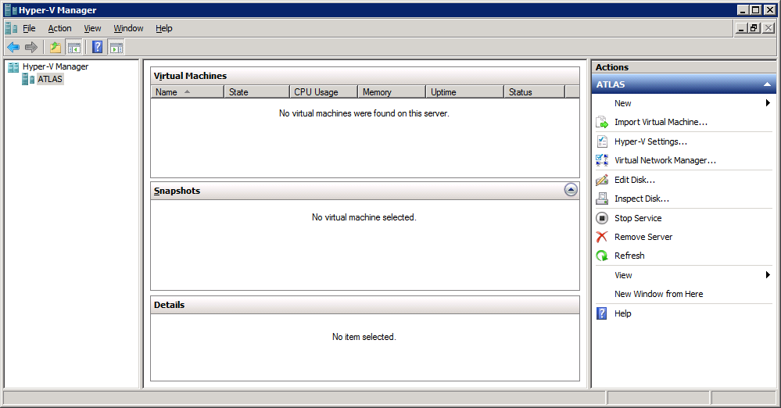

1. Create a new Virtual Network to connect to the Internet.
   1. In the Actions pan on the right-hand side of the screen, click **Virtual Network Manager**.
   2. In the Virtual Network Manager dialog, create a new virtual network named **External.**
   3. Make sure the **Connection type** of the new virtual network is configured with a setting of **External** and point it to a network card on the host computer connected to the Internet.

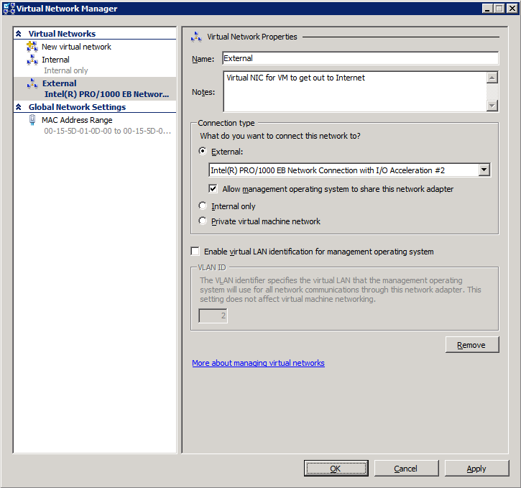

1. Create a new virtual machine to and prepare to install Windows Server 2008 R2 Enterprise
   1. Inside the left-hand side of the Hyper-V Manager, locate the node with the name of the local host computer. Right-click on this node and select **New » Virtual machine...**. When you execute this menu, command, the Hyper-V Manager will launch the New Virtual machine Wizard.

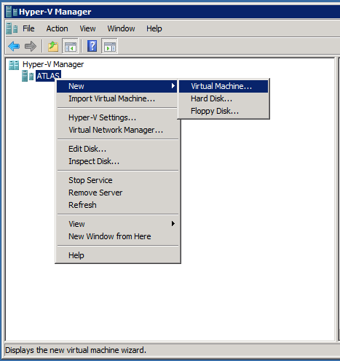

* 1. In the **Specify Name and location** dialog, enter a name of **WingtipServer**. Note that you can elect to store the files for the virtual machine in a different location. If possible, create the VM on a local hard drive that is different from one which contains the files for the host computer’s operating system. It will also improve your performance significantly if you are able to create your VM on a solid state drive.

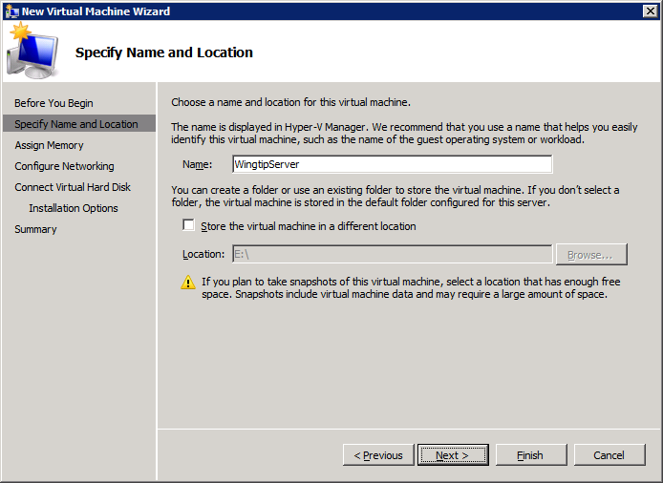

* 1. In the **Assign Memory** dialog, enter a **Memory** value according to this list. Note that your host machine requires at least 6GB of RAM.
     1. If your host machine has 6GB of RAM, enter a **Memory** value of **4092MB** (4GB)
     2. If your host machine has 8GB of RAM, enter a **Memory** value of **6144MB** (6GB)
     3. If your host machine has 12GB of RAM, enter a **Memory** value of **8192MB** (8GB)
  2. In the **Configure Networking** dialog, use the drop down box to assign a **Connection** value of **External** so that your new VM can use the Virtual Network you created earlier.
  3. In the **Connect Virtual Hard Disk** dialog, accept the default options to **Create a virtual hard disk**. If possible, configure the **Location** so that the .VHD file for the VM is created on a solid state drive to improve your performance.
  4. In the **Installation Options** dialog, choose the option to **Install an operating system from a boot CD\DVD-ROM**. To complete this step, you must have either a physical DVD or an .ISO file with the installation files for the 64-bit edition of Windows Server 2008 R2. If you have the installation files on a physical DVD, insert the DVD into a DVD drive on the host computer and then select reference it from the drop down menu in the **Media** section. If you have the installation files in .ISO file format, then select the radio for Image file (*.iso) and enter the path to the .ISO file.
  5. In the **Completing the New Virtual Machine Wizard** dialog, review the settings and click Finish to create the new VM.
  6. At this point you should be able to see the new VM named **WingtipServer** in the Virtual Machines section of the Hyper-V Manager.

1. Inspect and modify the setting for the new VM
   1. Right-click on the new VM named **WingtipServer** and select **Settings…** command.
   2. Inspect the current setting in the Processor section for the **Number of logical processors**. The default value for this property is 1. However, increasing the number of logical processors used by your VM can improve its performance. Therefore, you should set the number of logical processors to the maximum value. Note that the maximum number of logical processors is determined by the number of cores available on the host computer.

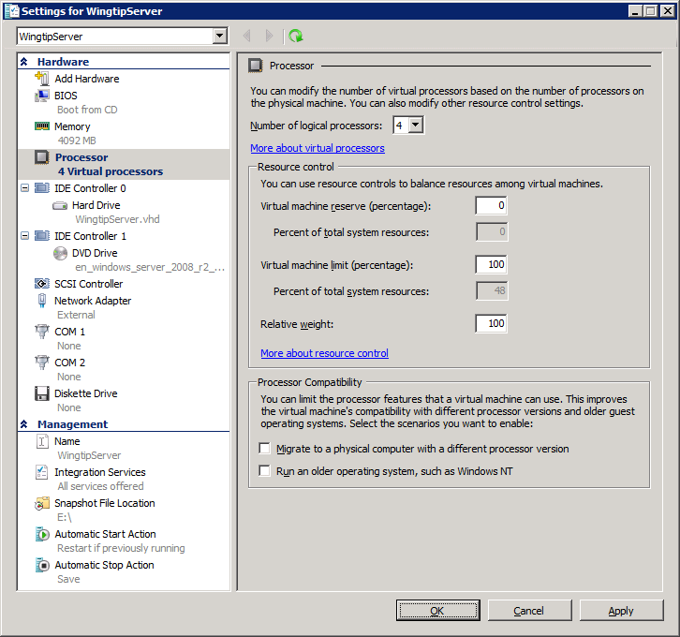

1. Start up the VM.
   1. Right-click on the VM named **Wingtipserver** and select the **Connect…** menu. This will launch the Virtual Machine Connection window for the VM.

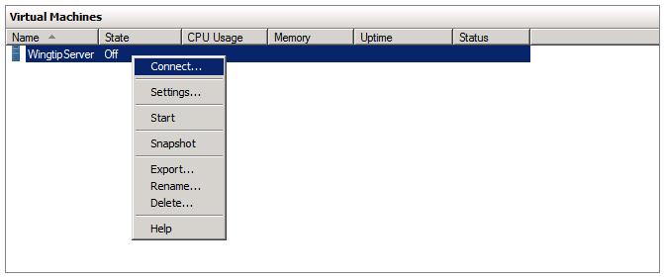

* 1. In the Virtual Machine Connection window, drop down the **Action** menu and select the **Start** command.

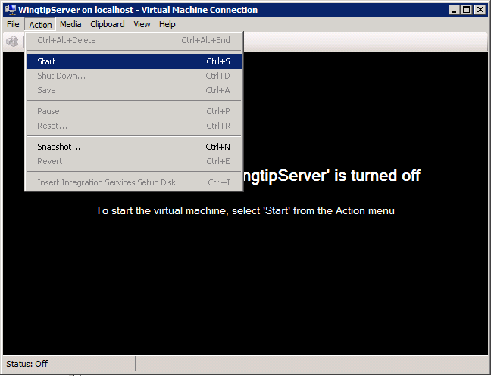

* 1. At this point you should be able to boot up the VM and see it discover installation files for Windows Server 2008 R2. Now you can move on to the next step which describes installing the operating system for Windows Server 2008 R2.

## Section 2: Install and Configure Windows Server 2008 R2

In this section, you will install and configure the operating system for Windows Server 2008 R2. Note that you should obtain a product key and the product installation files if you plan to install Windows Server 2008 R2.

If you do not have a product key or you plan to share the VM you are building with those not covered under your product key, you should download the free 180 day trial evaluation VM supplied by Microsoft as explained in **Appendix A: Download and Configure the Windows Server 2008 R2 Evaluation VM**. Appendix A will lead you through the steps of getting this free trial VM up and running so that you can use it as your starting point. If you choose to use the free trial VM, you should now move to Appendix A and work through all its steps. After completing the steps in Appendix A, you will be instructed to rejoin the steps below in this section.

Review to the following video for a walkthrough on the following steps: [**http://bit.ly/aeEpBg**](http://bit.ly/cPw8Xv).

1. Before you begin, verify that you followed the steps in Section 1 to accomplish the following.
   1. You created a new VM named **WingtipServer.vhd**.
   2. You have configured the VM with at least 4GB of RAM.
   3. You have configured the VM with the maximum number of logical processors.
   4. You have configured the VM with an external network card with an Internet connection.
   5. You have configured the VM so it can access the installation files for Windows Server 2008 R2 in either DVD or *.iso file format.
2. Install the operating system for Windows Server 2008 R2
   1. Start up the VM to begin the setup program for Windows Server 2008 R2. After the setup program for Windows Server 2008 R2 loads, it will prompt you with a dialog asking you to select a language. Accept the default of English and click **Install** to continue.

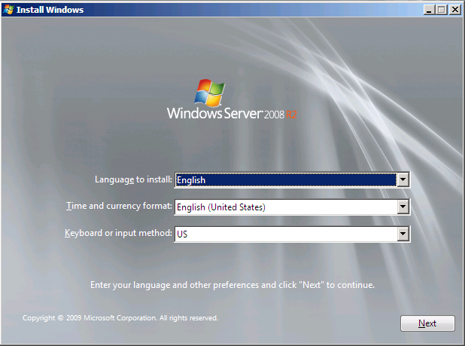

* 1. At the next dialog, click the **Install now** button to begin the installation.

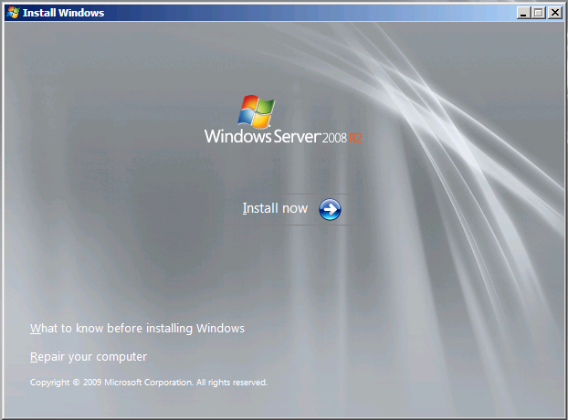

* 1. The next dialog instructs you to select the operating system you want to install. Select the operating system named **Windows Server 2008 R2 Enterprise (Full Installation)** with the **x64** architecture. Click **Next** to continue.
  2. Agree to the licensing terms and click **Next**.
  3. Click on **Custom (advanced)** to select the type of installation.
  4. The next dialog asks you where you want to install Windows. Accept the default configuration which uses a location of **Disk 0 Unallocated Space** as shown below. Click **Next** to continue.
  5. At this point you have given the Windows setup program enough information to install the basic operating system. Setup program will now run for a while as it copies and expands files and installs Windows features. You now have a few minutes to get a cup of coffee or catch up on email.
  6. When the setup program completes, it will ask you to assign a new password for the built-in **Administrator** account. Click **OK** to continue.
  7. Update the password for **Administrator** account to **Password1**.
  8. When you have updated the **Administrator** password, you will get a confirmation that the update was successful. Click **OK** to complete the installation of the operating system.

1. When you log in, Windows Server automatically displays the **Initial Configuration Tasks** window. Click the check box with the caption **Do not show this window at logon** and then click the **Close** button. After you close this window, Windows Server will display the **Server Manager**.

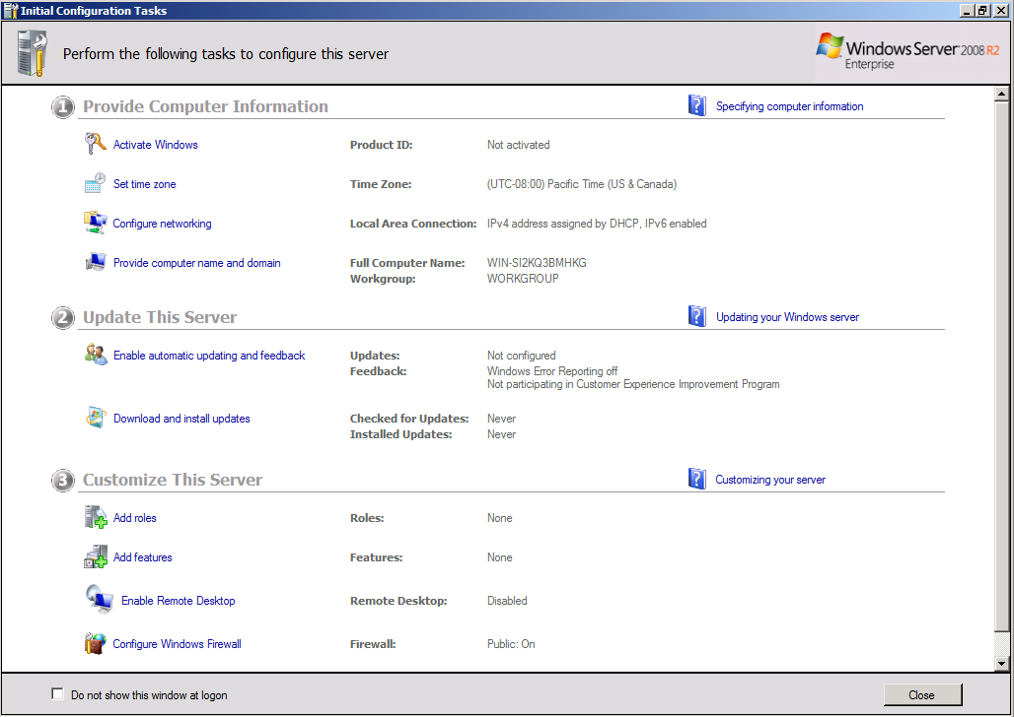

1. You should now looking at the Server Manager. If the Server Manager is not open, launch it from the Windows Start menu using **Start » Administrative Tools » Server Manager**.

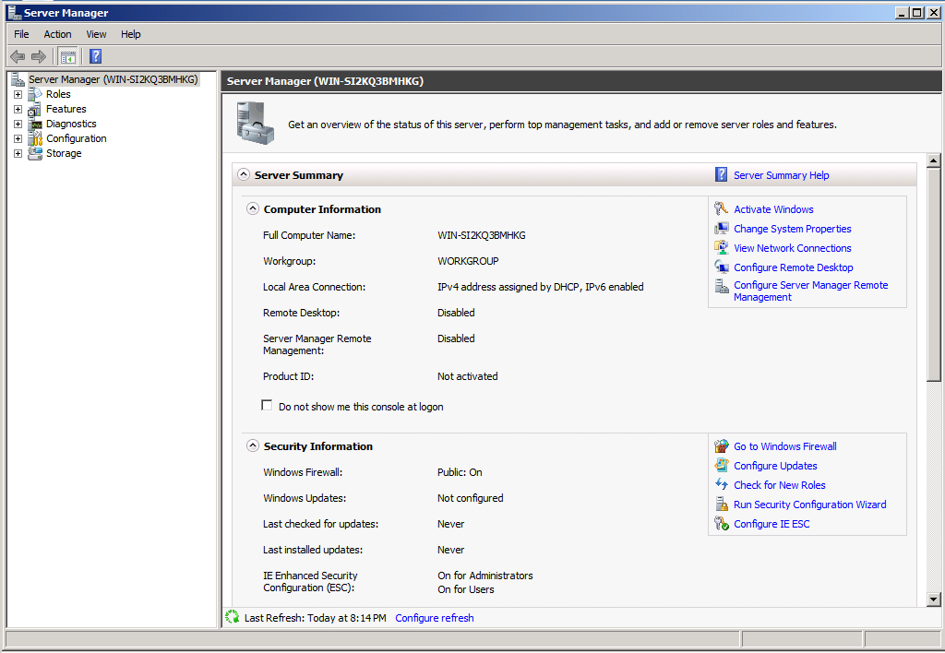

1. Configure the Administrator account so that its password does not expire.
   1. Inside the **Configuration** node of the **Server Manager**, navigate to **Local Users and Groups »** **Users** (as shown in the following screenshot) and locate the local **Administrator** account. Right-click on the **Administrator** account and click **Properties**.

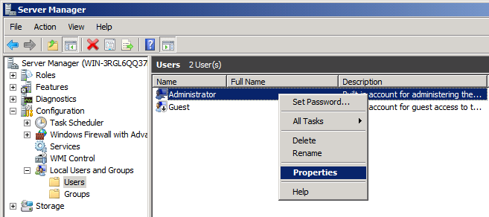

* 1. In the **Administrator Properties** dialog, unselect the option for **User must change password at next logon** and select the option for **Password never expires**. Click **OK**.

1. Rename the computer name of the VM to **WingtipServer**.
   1. In the **Server Manager**, navigate to the top-level node to display the **Server Summary** page. Click **Change System Properties**.

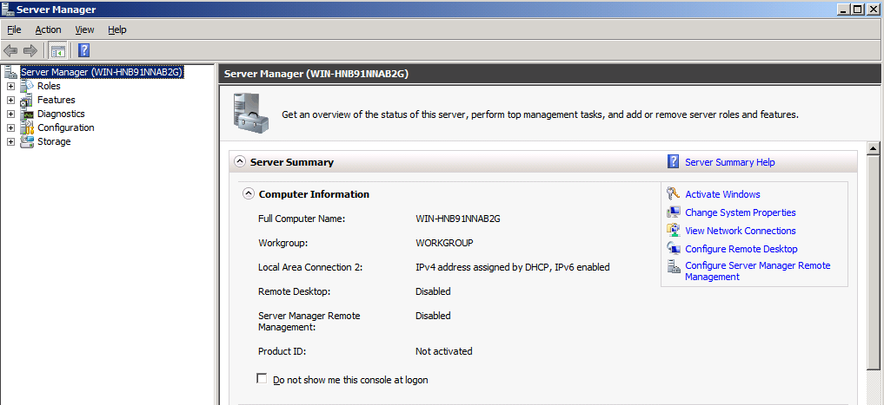

* 1. On the **Computer Name** tab of the System Properties dialog, click the **Change** button.

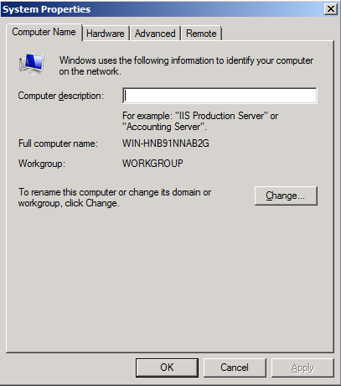

* 1. Enter a new computer name of **WingtipServer** and click **OK**. Note there is no need to change the Workgroup because you are going to create a new domain later.

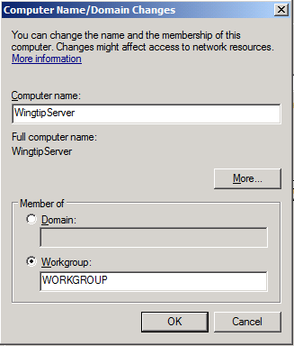

* 1. After changing the computer name you will be prompted to restart the VM. Choose **OK** to restart. After the VM has restarted, log in again using the same credentials as before.

1. Disable **Windows Firewall** and **Enhanced Security Configuration**.
   1. In the Server Manager, navigate to the top-level node to display the **Server Summary** page. Inside the **Security Information** section locate the links for **Go to Windows Firewall** and **Configure IE ECS**.

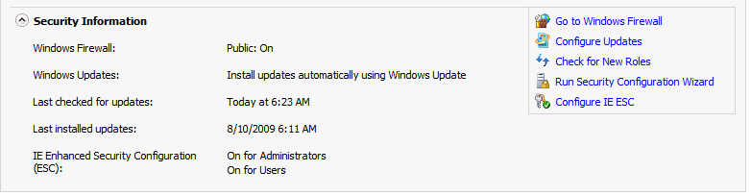

* 1. Click on Configure **IE ECS** link. Disable Enhanced Security Configuration for both Administrators and Users by selecting the **Off** radio buttons and click **OK**.
  2. Now click the **Go to Windows Firewall** link to display the page for the Windows Firewall. Click on the **Windows Firewall Properties** link at the bottom of the **Overview** section.
  3. In the **Domain Profile** tab of the Windows Fire dialog, change the **Firewall state** property setting from **On** to **Off**. Click to **Apply** button to save your changes. Once you have turned off the firewall in the Domain Profile tab, go to the **Private profile** tab and the **Public profile** tab and follow the same steps to disable the firewall for these profiles as well. Click **OK** to dismiss the Windows Firewall dialog once you have turned off the firewall for all three profiles.

1. Enable the Windows Server Features for the **Desktop Experience** and the **PowerShell Integrated Scripting Environment**.
   1. In Server Manager, choose **Add Feature** to bring up the Add Features Wizard dialog.
   2. Select the feature **Desktop Experience**.

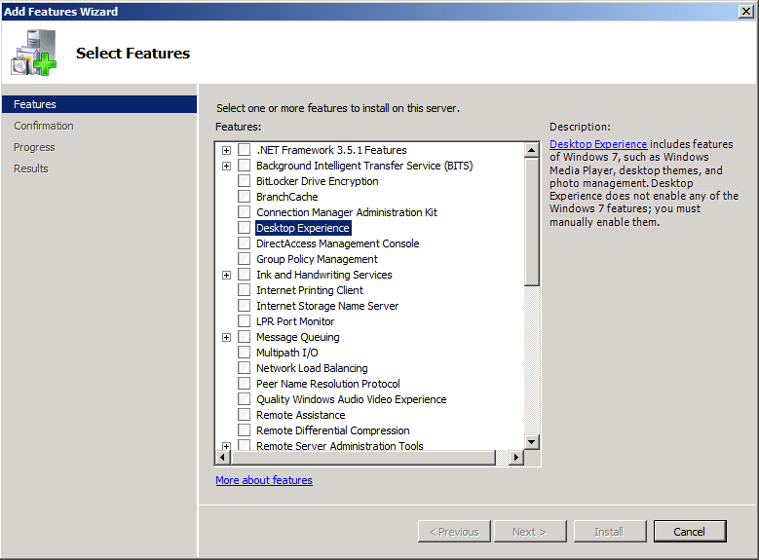

* 1. Note when you first click the checkbox for the **Desktop Experience**, the wizard will prompt you with the following dialog to add support for Ink and Handwriting Services. Click the **Add Required Features** button to continue.
  2. Scroll down the list of features in the **Add Features Wizard dialog** and select the feature **Windows PowerShell Integrated Scripting Environment (ISE)**.
  3. Note when you first click the checkbox for the **Windows PowerShell Integrated Scripting Environment (ISE)**, the wizard will prompt you with the following dialog to add support for .NET Framework 3.5.1 Features. Click the **Add Required Features** button to continue.
  4. Now that you have selected these two features for installation, click the **Next** button on the **Add Features Wizard dialog** to continue with the install. The next screen you will ask you to Confirm Installation Selections. Click the **Install** button.
  5. When you see the **Installation Results** screen, the Add Features Wizard informs you a computer restart is required. Click **Close** button to dismiss this dialog.
  6. The final dialog of the **Add Features Wizard** prompts you to restart the VM. Click **Yes** to begin the rebooting process.
  7. After the VM has restarted, login again as **Administrator**. Once you login, the feature installation process for Desktop Experience will automatically continue and complete.

1. Configure the **DisableLoopbackCheck** registry setting (Microsoft KB #896861).
   1. Launch the Windows Registry Editor. To do this click **Start**, click **Run**, type **regedit**, and then click **OK**.

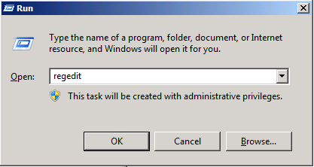

* 1. In Registry Editor, locate and then click the following registry key:

HKEY_LOCAL_MACHINE\SYSTEM\CurrentControlSet\Control\Lsa

* 1. Right-click Lsa, point to New, and then click **DWORD (32-bit) Value**.

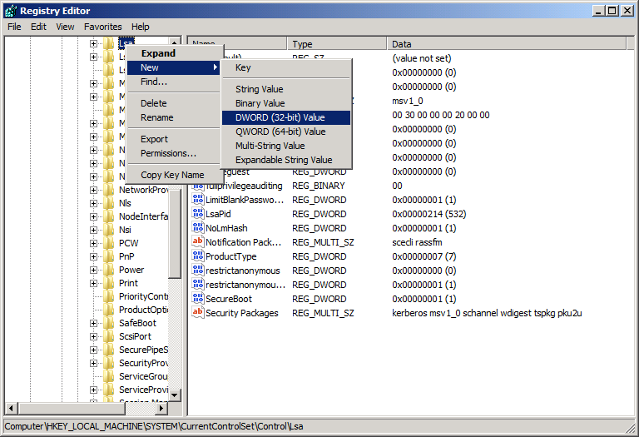

* 1. Type **DisableLoopbackCheck**, and then click Enter.
  2. Right-click **DisableLoopbackCheck**, and then click **Modify**.
  3. In the **Value data** textbox, type **1**, and then click **OK**.

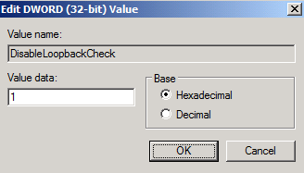

* 1. Quit Registry Editor.

1. Enabled Remote Desktop for your VM:
   1. In the **Server Manager**, navigate to the top-level node to display the **Server Summary** page. Inside the **Computer Information** section, locate and click the link for **Configure Remote Desktop**. In the Remote tab of the **System Properties** dialog, select the last option for **Allow connections only from computers running** **Remote Desktop with Network Level Authentication**. Click **OK** to save changes and dismiss the **System Properties** dialog.

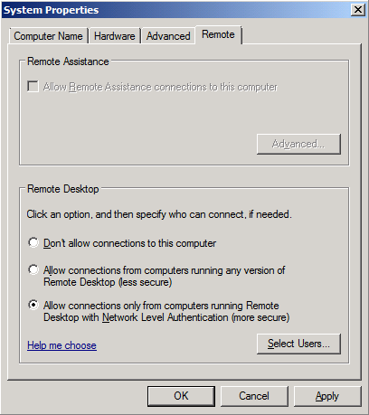

* 1. Now you should be able to connect through an RDP session. Many people prefer an RDP connection instead of the Hyper-V console. If you want to connect to this VM through an RPD connection, bring up a command prompt and run the **ipconfig** command to determine the IP address that has been assigned to your VM. Now you should be able to connect to your VM using RDP from another computer by using this IP address.

1. If you have a product key for Windows Server 2008 R2, use it to activate Windows.
   1. In the Server Manager, navigate to the top-level node to display the **Server Summary** page. Click **Activate Windows**.
   2. You will be prompted to enter your product key. Enter your product key and click to button to activate Windows. After a few seconds, your VM should be able to connect to a Microsoft site and successfully activate Windows.

### Install Active Directory Domain Services

Now you will promote your VM to a domain controller and create a new domain named **wingtip.com**

1. Add and configure the role for Active Directory Domain Services
   1. Launch **Server Manager** and select the **Roles** node. You should see there are no roles have been installed
   2. Click the **Add Roles** link to start the Add Roles Wizard.
   3. On the Before you begin page, click **Next**
   4. On the **Server Roles** page, Select **Active Directory Domain Services**. If will are prompted with a dialog which asks to install **Microsoft .NET Framework 3.5.1**, click the **Add Required Features** button to dismiss this dialog. Click **Next** to advance the Add Roles Wizard.

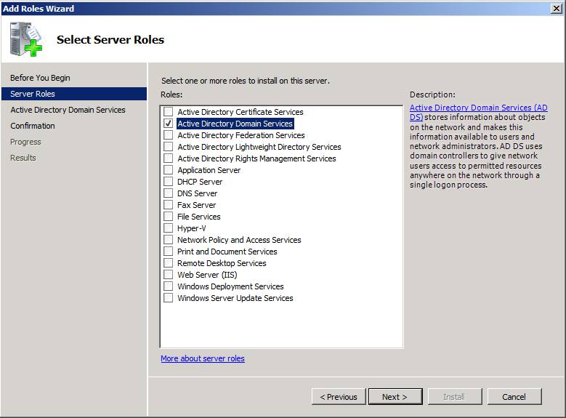

* 1. On the next page of the wizard, click **Next** which will bring you to the **Confirm Installation Selections** page. Click **Install**.
  2. After Active Directory Domain Services has been installed, you will see the **Installation Results** page in the Add Roles Wizard as shown below. Click on the link with the big long caption of **Close this wizard and launch the Active Directory Domain Services Installation Wizard (dcpromo.exe)**.
  3. On the first page of the **Active Directory Domain Services Installation Wizard**, click the **Use advanced Mode installation** check box and click Next.

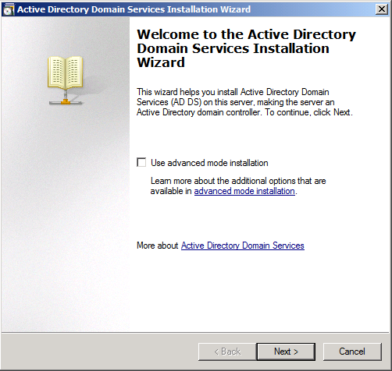

* 1. When you see the **Operating System Compatibility** page, click **Next**.
  2. The next page asks you to **Choose a Deployment Configuration**, select the option to **Create a new domain in a new forest** and click **Next**.
  3. The next page asks you to **Name the Forrest Root Domain**. Enter **wingtip.com** into the **FQDN of the forest root domain** textbox for the root domain and click **Next**.
  4. The next page asks you to **Set Forest Functional Level**. Using the dropdown list, change the setting to **Windows Server 2008 R2** and click **Next**.
  5. The next page asks you to set **Additional Domain Controller Options**. You should be able to accept the default options as shown below. Click **Next**.

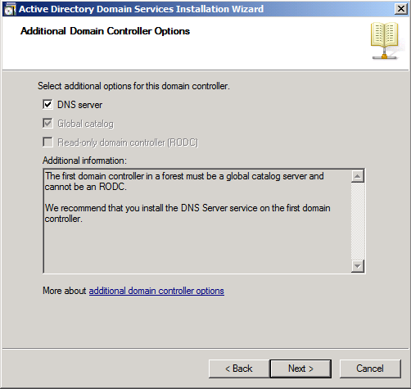

* 1. You might be prompted with the dialog shown below providing a warning that **This computer has dynamically assigned IP address(es)**. This is not a problem when you are running your development environment on a domain controller. Click **Yes** to dismiss the dialog.

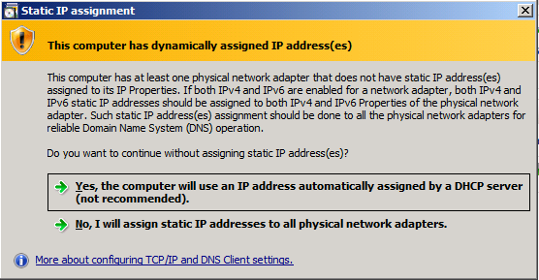

* 1. At this point the wizard will prompt you with a dialog information you a delegation for the DNS Server cannot be created because it cannot find the authoritative parent zone. This is not a problem because the wizard will automatically configure the DNS of the VM to point to itself. Click on the **Yes** button to dismiss this dialog.

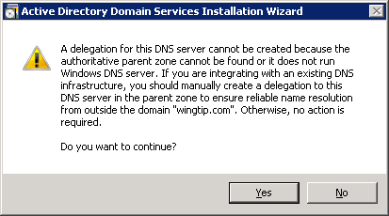

* 1. The next page asks you to set values for **Location for Database Log Files and SYSVOL**. Accept all the default values by clicking **Next**.
  2. The next page asks you to provide and confirm a password for **Directory Services Restore Mode Administrator Password**. Add a password of **Password1** and click **Next**.
  3. The next page is the **Summary** page which should show the values below. Click **Next** to start the process of configuring the new Active Directory domain.
  4. The wizard will display the dialog below to show you the progress of the configuration process. You will be required to reboot when the configuration has been completed. Check the option for **Reboot on completion** and then wait for the configuration to complete and the machine to reboot.

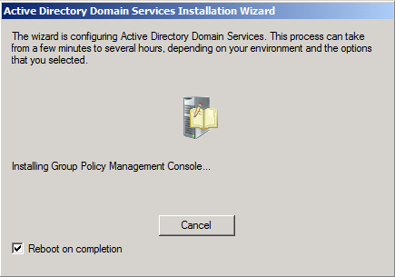

* 1. After the VM reboots, you should logon using the domain account **WINGTIP\Administrator**. The password should still be **Password1**.

### Configure Windows Update

As the final part of this step, you will configure Windows Update.

1. Select **Start » All Programs » Windows Update**.
2. First, disable Windows Update from running automatically:
   1. Click the link **Change Settings**.
   2. Under the **Important Updates** list, select **Never check for updates (not recommended)**. This isn’t what you would do in a production environment, but for a development machine it is ok.
3. Now update the server. First select the **Check for Updates** link.
   1. Windows Update will the report how many updates are available. Select all important and recommended updates. Then click the **Install Updates** button.
   2. If prompted, select **I accept the license terms** for any updates that require it.
   3. When Windows Update completes, it’s a good idea to go ahead and reboot. Once the server has rebooted, login again.

## Section 3: Install SQL Server 2008 R2 Enterprise

In this section, you will install the Enterprise edition of SQL Server 2008 R2. Below we provide a link which will allow you to download a free trial version which will expire after 180 days. If you have a licensed version of SQL Server 2008 R2, you can alternatively install that so that the software does not expire after 180 days.

Review to the following video for a walkthrough on the following steps: [**http://bit.ly/a0WYdZ**](http://bit.ly/94poZ4).

1. Follow these steps if you plan on using the free trial version of SQL Server 2008 R2. Note that this free trial version is set to expire in 180 days after installation. If you have a registered version of SQL Server 2008 R2 through a subscription to MSDN or TechNet or by other means, you can install that instead of the free trial version in order to having the software expire.
   1. In the browser, navigate to the page at the link below.

[http://technet.microsoft.com/en-us/evalcenter/ee315247.aspx](http://intranet.wingtip.com) or [http://bit.ly/9lrVe0](http://bit.ly/df0NIJ)

* 1. Follow the instructions to download the 64-bit edition of SQL Server 2008 R2. The download is a self-extracting file named **SQLFULL_x64_ENU.exe**.
  2. Once downloaded, double click **SQLFULL_x64_ENU.exe** to begin the extraction process**.**
  3. After downloading, extract the contents.

**Note:** If you are using a licensed copy, you will likely have an *.ISO file which you can mount to the DVD Drive of the VM.

1. Logon to the VM and begin the installation of SQL Server 2008.
   1. Logon to the VM as **Wingtip\Administrator**
   2. Open the Widows Explorer navigate to the DVD drive.
   3. Double click on **setup.exe** to begin the installation process.
2. The setup process should now show the following window. Click the **Installation** link on the left-hand side of the window and then click the link which reads **New SQL Server stand-alone installation or** **add features to an existing installation**.
3. The setup program will then check to make sure there were no problems with the setup rules. Once passed, click **OK**.

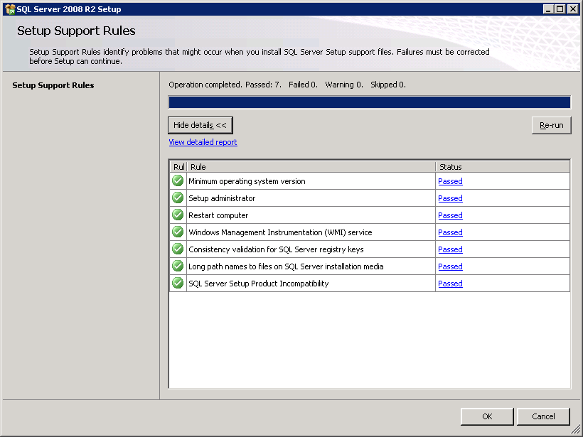

1. There are several windows at the beginning of the installation process that you should click **Next** to advance the installation process. At the **Product Key** page, select the **Enterprise Evaluation** or plug in your license key and click **Next** to continue.
2. When prompted on the **License Terms** dialog, click **I accept the license terms** and click **Next**.
3. The next page is the **Setup Support Files** page. Click **Install** to continue.
4. When you get to the **Setup Support Roles** page of the setup wizard, the installation process runs tests to make sure your VM meets the requirements. Your VM should pass all tests and the only warning you should receive is that you are installing SQL Server 2008 on a domain controller. You can ignore this warning. Click **Next** to continue.

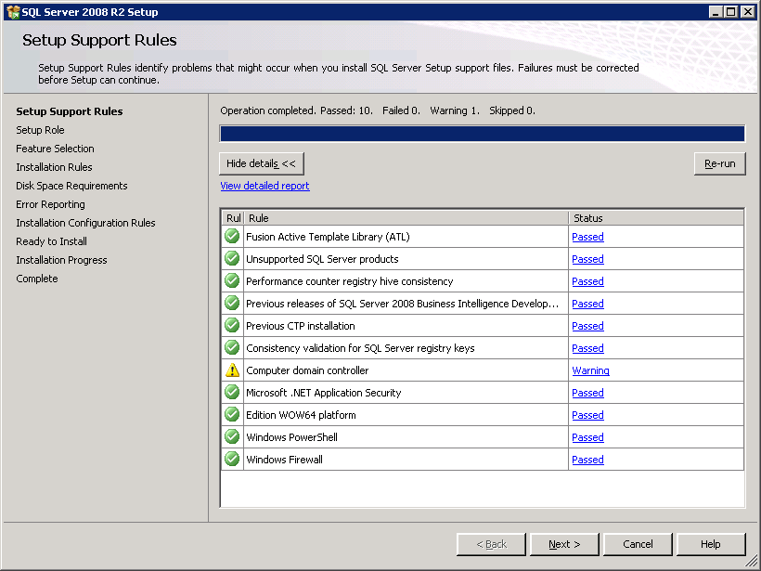

1. On the **Setup Role** page, select **SQL Server Feature Installation** and click **Next**.

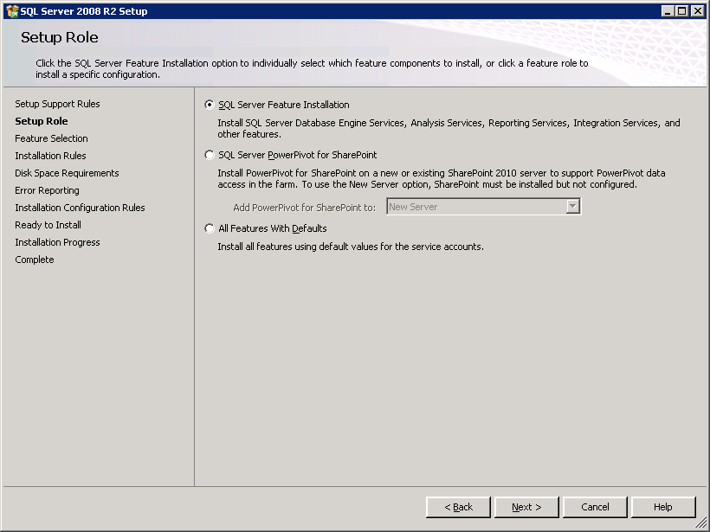

1. When you get to the **Feature Selection** page, select the following features and click **Next** to continue (also refer to the following screenshot for reference):
   1. Database Engine Services
      1. SQL Server Replication
      2. Full-Text Search
   2. Analysis Services
   3. Reporting Services
   4. Business Intelligence Development Studio
   5. Management Tools – Basic
      1. Management Tools - Complete
   6. Microsoft Sync Framework

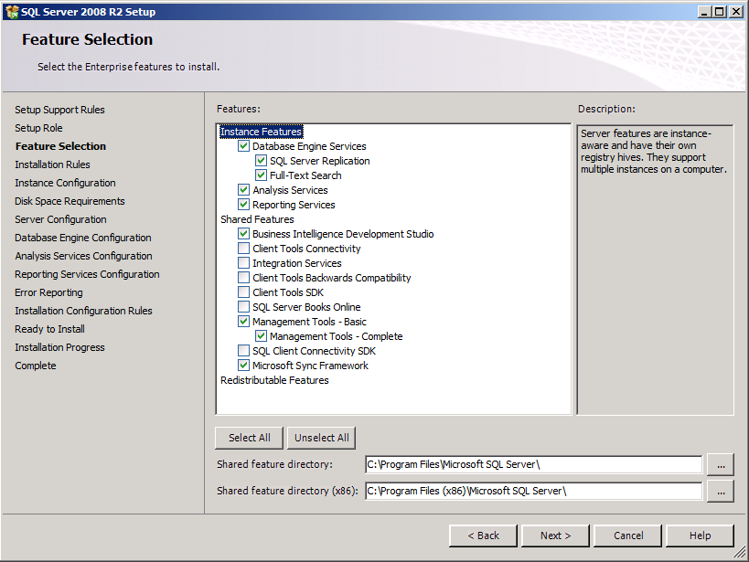

1. Click **Next** on the **Installation Rules** dialog.
2. There is nothing to change on the **Instance Configuration** page. Click **Next** to continue.
3. Click **Next** on the **Disk Space Requirements** dialog.

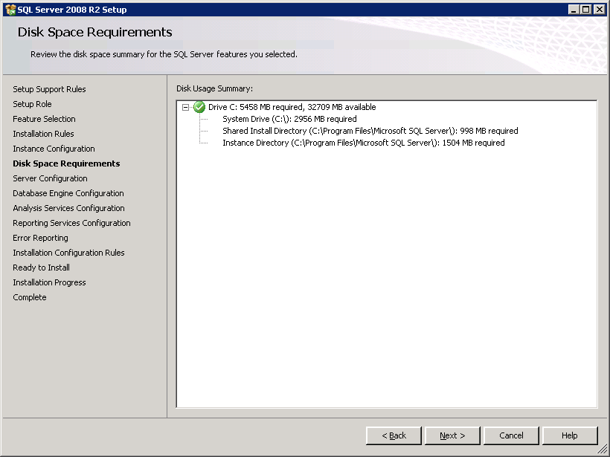

1. The next page is the **Server Configuration** page. Change the **StartUp Type** setting for the SQL Server Agent to be **Automatic**. Click the button with the caption of **Use the same account for all SQL Server instances**. When the dialog appears to select a user account, select the System account (**NT AUTHORITY\SYSTEM**) and click **OK**.

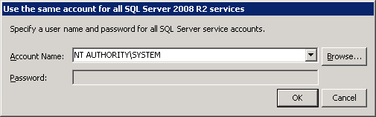

**NOTE:** In a real production environment, SQL Server 2008 R2 processes should be configured to run under a dedicated service account and not under the System account.

1. After you have completed the previous step, the **Server Configuration** page should appear like the one shown below. Now click on the **Collation** tab.

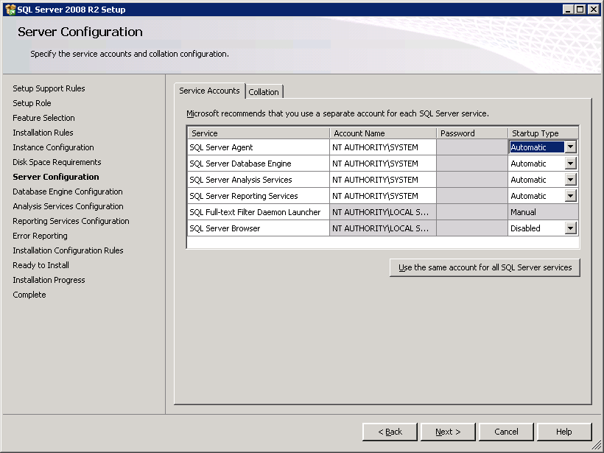

1. On the **Collation** tab, you will see default collation settings for both the **Database Engine** and for **Analysis Services**. Each setting has a **Customize…** button to its right. Click the **Customize…** button for each of these two settings and fill out the resulting dialog with the collation setting shown in the screenshot below. This step ensures you have the best collation setting for SharePoint 2010 which is **LATIN1_General** with the options for **Case Insensitive (CI)**, **Accent-sensitive (AS)**, **Kana-sensitive (KS)** and **Width-sensitive (WS)**.

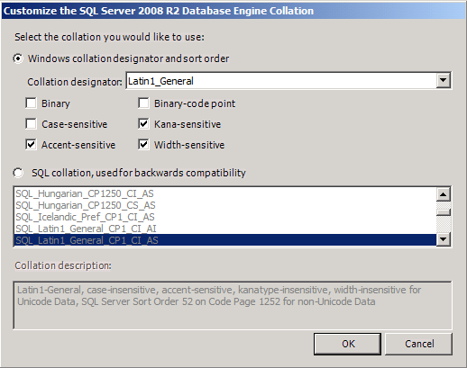

1. Once you have changed the collation, the **Server Configuration** dialog should look like the one below. Click **Next** to continue

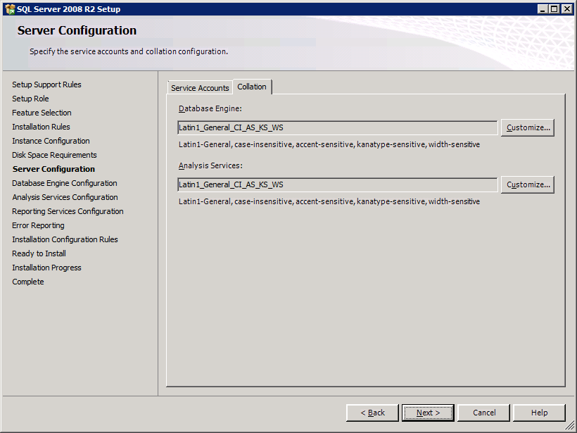

1. The next page is the **Database Engine Configuration** page. Specify **WINGTIP\Administrator** as a SQL Server administrator by clicking the **Add Current User** button at the bottom of the page. After the page looks like the one below, click on the **FILESTREAM** tab so that you can make changes there.
2. On the **FILESTREAM** tab of the **Database Engine Configuration** page, select the options for **Enable FILESTREAM for Transact-SQL access** and **Enable FILESTREAM for file I/O streaming access**. Click **Next** to continue.

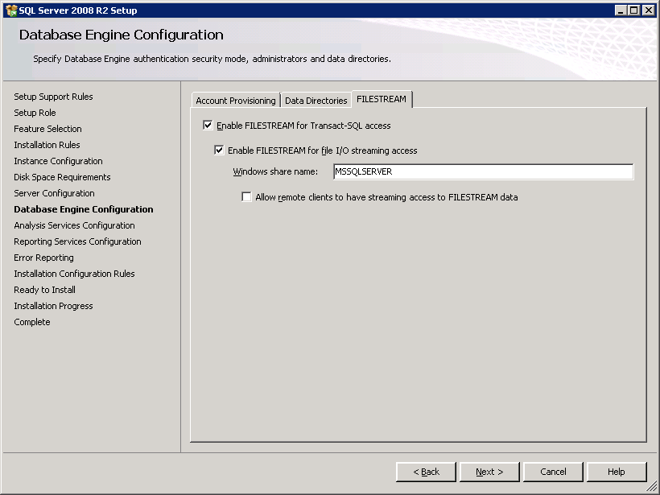

1. On the **Analysis Services Configuration** page, specify **WINGTIP\Administrator** as an Analysis Services administrator by clicking the **Add Current User** button at the bottom of the page. Click **Next** to continue.

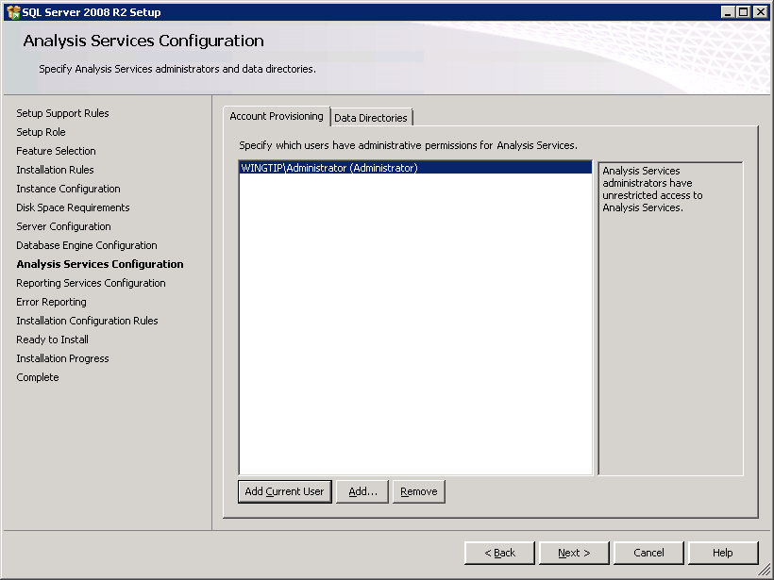

1. On the **Reporting Service Configuration** page, select the last option to **Install, but do not configure report server**. Click **Next** to continue.
2. At the **Error Reporting** page, click **Next**.
3. At the **Installation Configuration Rules** page, verify that your VM passes all tests. Click **Next** to continue.
4. On the **Ready to Install** page, click **Install** to begin the installation. The installation will take somewhere between 5 and 30 minutes depending on your hardware performance.
5. When you get to the **Complete** page you are finished with the installation. Click the **Close** button.

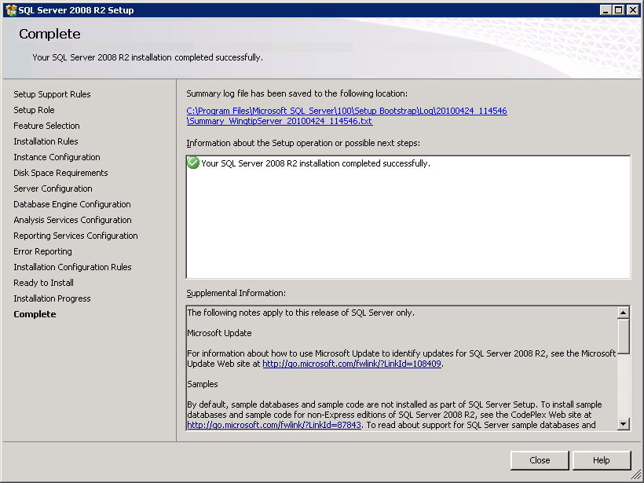

1. Now, you have completed the installation of SQL Server 2008 R2. Now you can optionally install the Adventure Works sample databases by going through **Appendix B: Create the Sample Adventure Works Databases**. Note that you can go through the steps of Appendix C right now or you can wait until you have completed the remaining sections.

## Section 4: Install and Configure SharePoint Server 2010

Now it is time to install SharePoint Server 2010. You will begin by installing the released version of WCF Data Services for .NET 3.5. The installation of this component is required to make REST-based Web services work properly in SharePoint Foundation. Next, you will install SharePoint Server 2010 and create a new farm. Within this farm you will create and configure a new Web application and configure several of the service applications supplied by SharePoint Server 2010.

Review to the following video for a walkthrough on the following steps: [**http://bit.ly/a9Vo68**](http://technet.microsoft.com/en-us/evalcenter/ee315247.aspx).

1. Install **WCF Data Services**.
   1. In the browser, navigate to the download page using the URL below. Note that the download page is titled with the old name which is *ADO.NET Data Services Update for .NET Framework 3.5 SP1 for Windows 7 and Windows Server 2008 R2*.

[http://www.microsoft.com/downloads/details.aspx?FamilyID=3e102d74-37bf-4c1e-9da6-5175644fe22d](http://intranet.wingtip.com?FamilyID=3e102d74-37bf-4c1e-9da6-5175644fe22d?FamilyID=3e102d74-37bf-4c1e-9da6-5175644fe22d) or [http://bit.ly/9R2ju8](http://intranet.wingtip.com).

* 1. Locate and download the file **Windows6.1-KB976127-v6-x64.msu**.
  2. Double-click on **Windows6.1-KB976127-v6-x64.msu** to run the update.

In the next step you will create a new user account named **SP_WorkerProcess** that will serve as the identity for the worker pool processes used by SharePoint Server. You will create this account as a domain account in the WINGTIP directory as to simulate a production environment. Note, however, that this setup document reduces complexity by using a single user account to configure all SharePoint Server worker processes while a true production environment will likely employ multiple user accounts so that various Web Applications like Central Administration could have a unique identity.

1. Create new user account in Active Directory for SharePoint Worker Process identity
   1. Launch the Active Directory Users and Computers from the Windows Start menu  
      **Start » Administrative Tools » Active Directory Users and Computers**.
   2. Navigate to the **Users** node. Right click on this node and execute the **New » User** menu command as shown in the screenshot below.
   3. Create new account named **SP_WorkerProcess** by filling out the dialog as shown.
   4. Give the new user account a password of **Password1**.
   5. When you are done you should be able to verify you can see the new **SP_WorkerProcess** account inside the **Users** node.
   6. Configure access to SQL Server 2008 R2 for this account.
      1. Open **Start » All Programs » SQL Server 2008 R2 » SQL Server Management Studio**.
      2. When prompted, connect to the server **WINGTIPSERVER** using **Windows Authentication**.
      3. Expand the **Security** node, right-click **Logins** and select **New Login**.
      4. For the **Login Name** enter **WINGTIP\SP_WorkerProcess**.
      5. Select the **Server Roles** page on the left-hand portion of the **Login – New** dialog. Select the following roles and click **OK**:
         1. dbcreator
         2. public
         3. securityadmin
2. Download the SharePoint Server 2010 installation files and make them available to the VM:
   1. In the browser, navigate to the page at the link below.

[http://technet.microsoft.com/en-us/evalcenter/ee388573.aspx](http://bit.ly/9lrVe0) or [http://bit.ly/bcZ4S7](http://www.microsoft.com/windowsserver2008/virtualization/install.mspx).

* 1. Download the file named **SharePointServer.exe** to hard drive of host computer.
  2. Extract the setup files into a location where they are accessible to your VM. For example, if you downloaded **SharePointServer.exe** to the **c:\Install** directory on the local hard drive of your host computer, you can extract the SharePoint Server 2010 setup files into a child directory named **c:\Install\SharePoint2010** by running the following command from the command line.

c:\Install\SharePointServer.exe /extract:c:\Install\SharePoint2010

* 1. Double-click the **setup.hta** file in the installation folder to launch the installer utility:

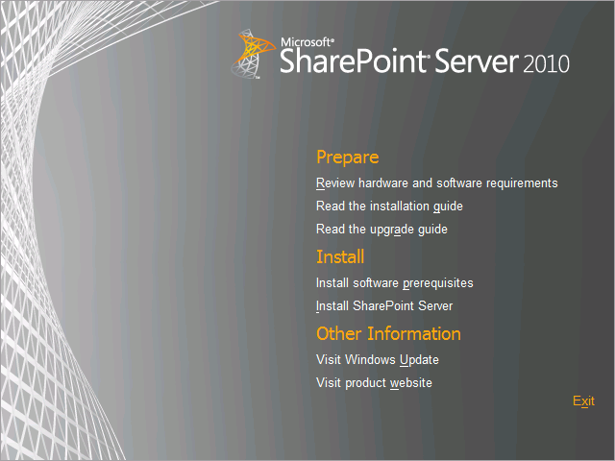

1. Run the **SharePoint 2010 Products Preparation Tool**:
   1. Click the link **Install software prerequisites** under the **Install** group.
   2. Click **Next** at the welcome screen to install the SharePoint Server prerequisites.

**Note:** Your virtual machine will need Internet access to download the required prerequisites. If you don’t have an internet connection you can download and manually install all the prerequisites using the information on this link: [http://technet.microsoft.com/en-us/library/cc262485.aspx](http://bit.ly/aDT3hj) or [http://bit.ly/9DyhlN](http://bit.ly/ckFjiN).

1. After running **SharePoint 2010 Products Preparation Tool**, reboot the machine and then log in again as **WINGTIP\Administrrator**.
2. Install **SharePoint Server 2010 Enterprise**:
   1. Inside the top-level directory of the SharePoint Server install files, locate and double-click **setup.exe** to launch the installation program.
   2. When prompted, enter your product key for SharePoint Server 2010.
   3. Accept terms of Agreement.
   4. In the **Choose a file** location dialog, accept the default setting and click Install Now to complete the installation of SharePoint Server 2010 Enterprise.
   5. When installation is completed, you are prompted with a checkbox labeled **Run the SharePoint Products and Technologies Configuration Wizard now**. Make sure this checkbox is checked and click **Close** to begin this wizard.
3. Use the Configuration Wizard Create the **Configuration Database** and **Central Administration Web application** using the SharePoint Products and Technologies Configuration Wizard
   1. On the **Welcome to SharePoint Products** page, click **Next** to continue.
   2. A dialog will ask you whether it is OK to stop IIS and a few other services. Click **Yes** on this dialog to continue with the configuration process.
   3. On the **Connect to a server farm** page, Select **Create a new server farm** and click **Next** to continue.

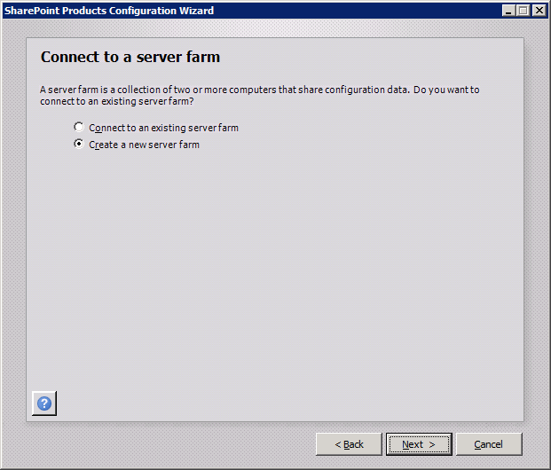

* 1. The next page is the **Specify Configuration Database Settings** page. Fill in these settings with these value.  
     Database server: **WingtipServer**Database name: **Wingtip_ConfigDB**Username: **Wingtip\SP_WorkerProcess**Password: **Password1**

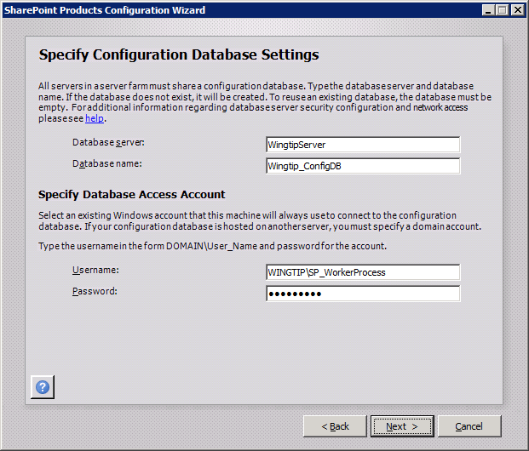

* 1. One you filled in the configuration database settings, click **Next** to continue.
  2. The next page is the **Specify** **Farm Security Settings** page which asks you to add and confirm a passphrase. Add and confirm a passphrase value of **Password1** and click **Next** to continue.

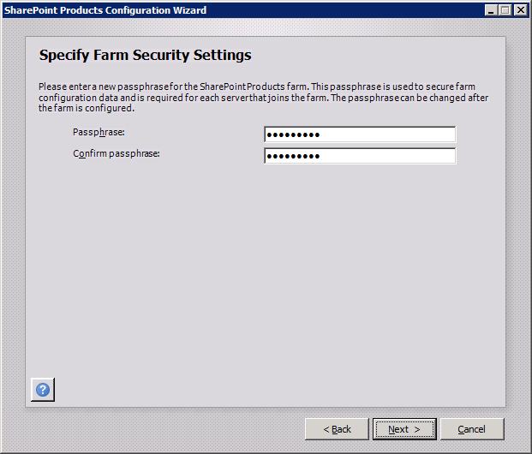

* 1. On the Configure SharePoint Central Administration Web Application page, select the option to **Specify port number** and add a port number value of **9999**. Leave the **Configure Security Settings** authentication provide settings at the default value of **NTLM**. Click **Next** to continue.

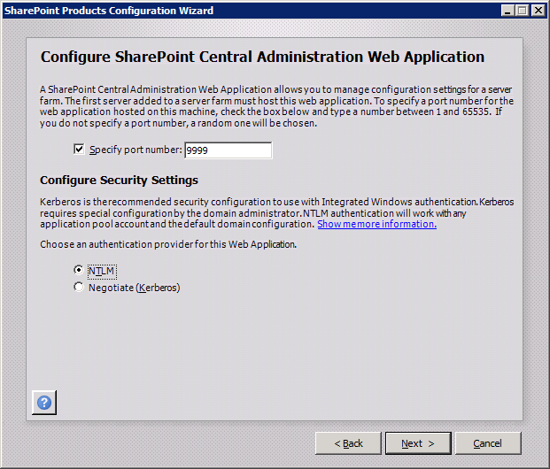

* 1. Review your configuration settings in the **Completing the SharePoint Products Configuration Wizard** page. Click **Next** to begin the configuration.

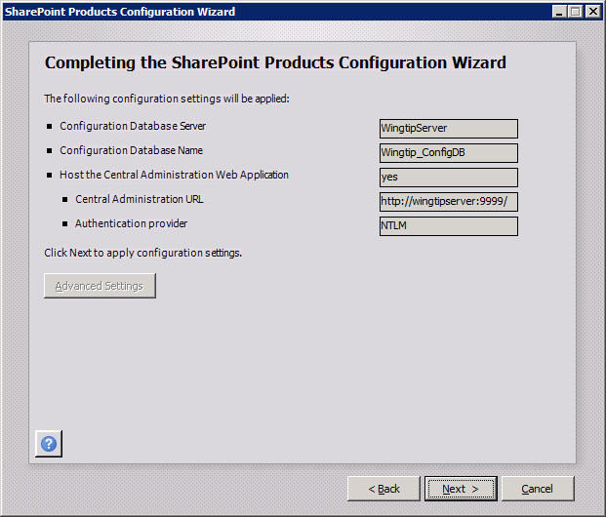

* 1. SharePoint will now begin configuring itself which should take 5-10 minutes depending on the performance of your hardware. When you are done, you will a page with the title of **Configuration Successful**.
  2. Click the **Finish** button and you will be directed to a page in Central Administration at the URL of [http://wingtipserver:9999/_admin/adminconfigintro.aspx](http://www.microsoft.com/downloads/details.aspx). This page starts the **Farm Configuration Wizard**.

1. Configure the farm’s service applications using the **Farm Configuration Wizard**.
   1. The first dialog of the **Farm Configuration Wizard** asks you whether you want to participate in the **Customer Experience Improvement Program**. Select the option **No, I don’t wish to participate** and click **OK** to continue.

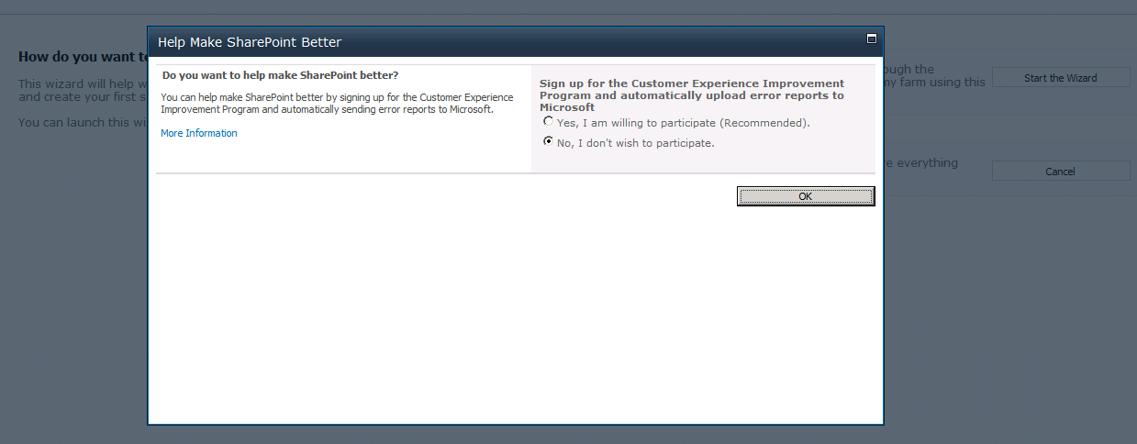

* 1. The next page of the wizard asks **How do you want to configure your SharePoint farm?** Select the option **Yes,** **Walk me through the settings using the wizard.** Click **Start the Wizard** to continue.

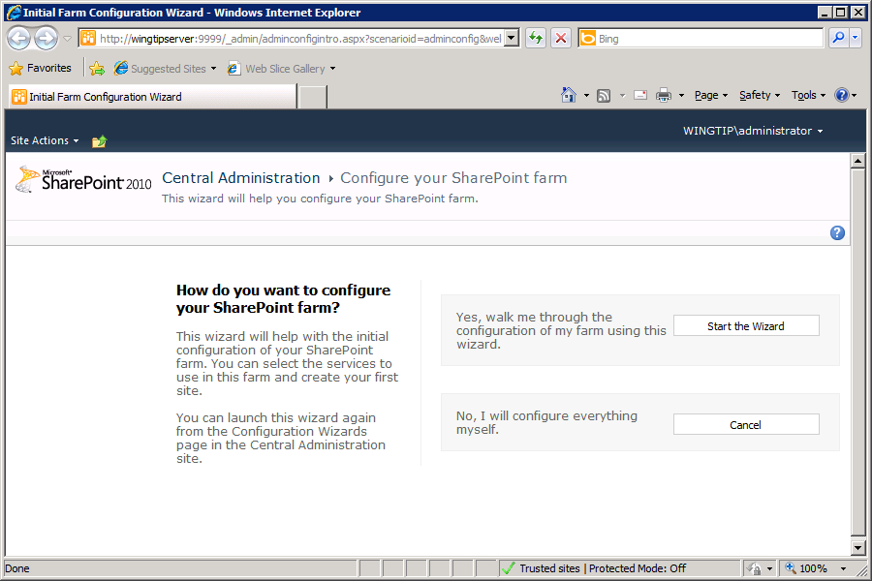

* 1. Next page of the **Farm Configuration Wizard** asks you to select a service account for running the farm’s service applications. Select the option to **Use existing managed account** and make sure the domain account **WINGTIP\SP_WorkerProcess** is selected. You do not need to change anything in the **Services** section because you can accept the default selections. Click **Next** to continue.

Now the Configuration Wizard is going to run for a while.

* 1. In addition to provisioning the farm’s service applications, the Farm Configuration Wizard also creates a new Web Application using the URL of the machine name (**http://WingtipServer**) and asks you if you want to create a new site collection at the root. Give it a **Title** of **Wingtip Test Site**, Select the site template named **Team Site** and click **OK** to continue.

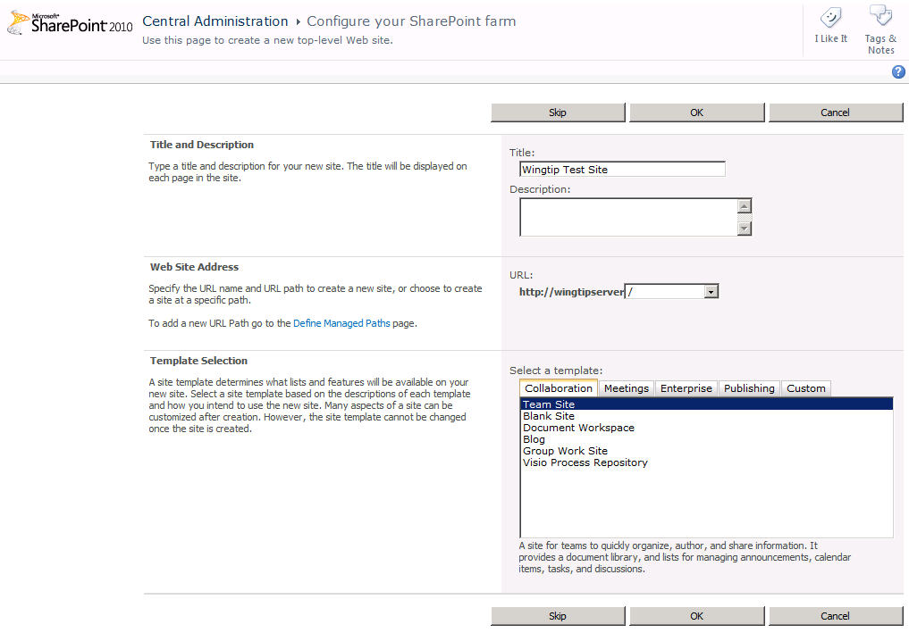

* 1. Now you are finished with the **Farm Configuration Wizard**. Click **Finish**.

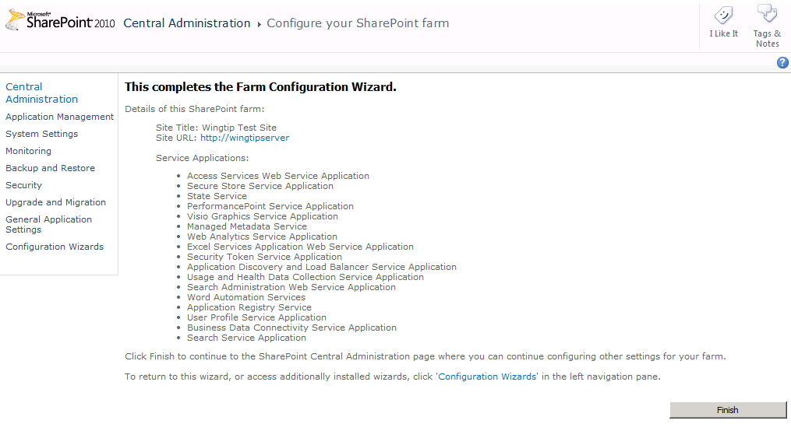

* 1. When the **Farm Configuration Wizard** completes, it will redirect you to the home page of the Central Administration application.

### Post-Installation Configuration of SharePoint Server 2010

1. You have now completed the basic installation of SharePoint Server 2010 and you have created the configuration database to establish a new farm. Now you will turn on two services that are not automatically turned on by default.
   1. On the home page of Central Administration, locate and click the link with the caption **Manage services on this server**.

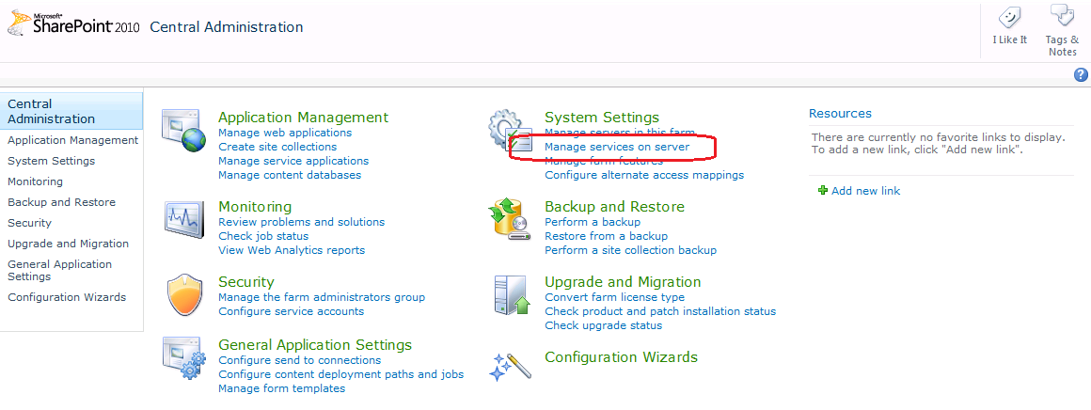

* 1. On the **Services on Server** page for WingtipServer, you must start two services named **Claims to Windows Token Service** and **Microsoft SharePoint Foundation Sandboxed Code Service**. You can do this by clicking on the **Start** link in the **Action** column over to the right of the service name.

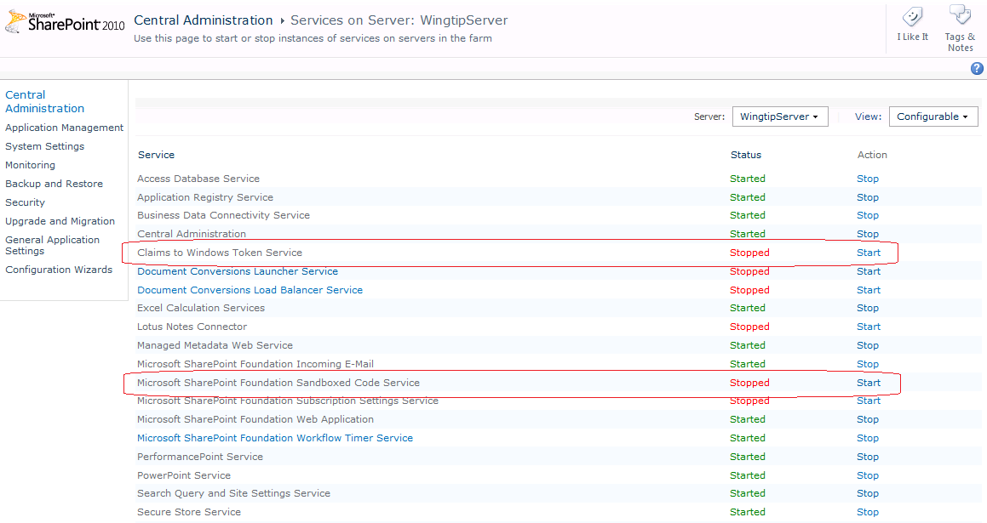

1. At this point you can optionally install the Microsoft Office Web Applications so that you add the functionality required to open and edit Word documents and PowerPoint slide decks through the browser. To accomplish this work through the steps of **Appendix D: Install the Office Web Applications** and then return here and continue on at the next step. Note that installing the Microsoft Office Web Application is required when building a VM for any Critical Path Training courses.

### Create a New Web Application

Now you will create and configure a new Web Application at the URL of **http://intranet.wingtip.com**. You must begin by configuring DNS with Windows Server 2008 R2 and then you will use the Central Administration application to create and configure the new Web Application.

1. Now it’s time to configure DNS settings to configure URLs such as [http://intranet.wingtip.com](http://bit.ly/cfrO0P) so they are redirected to the local loopback address. Since this is a development workstation (and not a production server), you will use a shortcut to redirect DNS names using an lmhost file.

The biggest benefit to using the lmhost file approach for configuring DNS names is that your DNS settings will not be affected by changes to the VM's network card such as switching between a dynamic IP address and a static IP address. In fact, the DNS setting will work fine even when your VM has no Internet connection. This is the only approach you should use when configuring DNS on a demo machine.

* 1. In the Windows explorer, navigate to the directory at C:\Windows\System32\drivers\etc\. Locate the file which has the name hosts and no file extension.

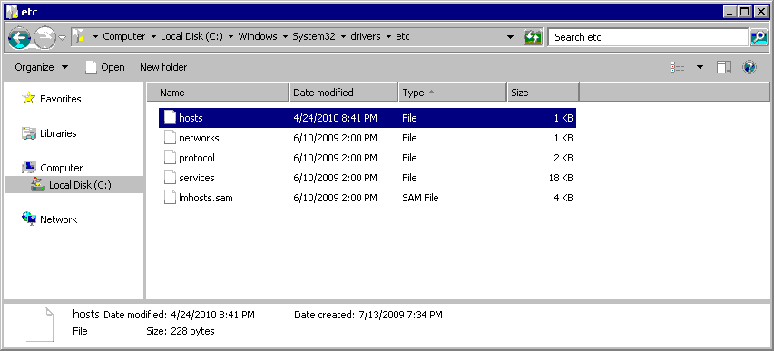

* 1. Open the hosts file using NOTEPAD.EXE. Delete the entire contents of the hosts file and replace it with the following text.

# Wingtip DNS Settings for testing and development  
  
127.0.0.1 intranet.wingtip.com

::1 intranet.wingtip.com

127.0.0.1 extranet.wingtip.com

::1 extranet.wingtip.com

127.0.0.1 www.wingtip.com

::1 www.wingtip.com

* 1. Save your work.

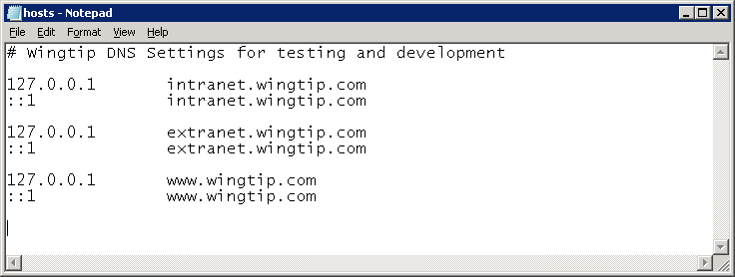

* 1. Verify the new DNS setting works properly by bringing up a Windows command prompt and running the DOS **ping** command on the address of [**http://intranet.wingtip.com**](http://bit.ly/aeEpBg).

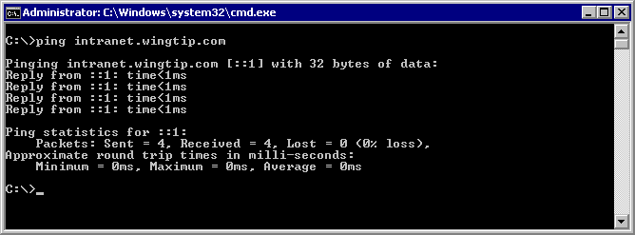

1. Create a new Web Application at the URL of [**http://intranet.wingtip.com**](http://technet.microsoft.com/en-us/office/ee815687.aspx).
   1. Navigate to the home page of the Central Administration application. If it is not already running, launch it from **Start » All Programs » Microsoft SharePoint 2010 Products » SharePoint 2010 Central Administration**.
   2. Inside the **Application Management** section, click on the link with the caption of **Manage web applications** to navigate to the **Web Application Management** page.
   3. Make sure the **Web Application** tab is selected. Click the **New** button on the very left-hand side of the Ribbon.

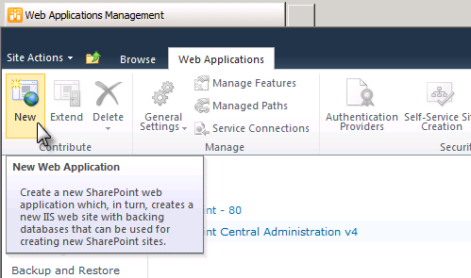

* 1. The **Create New Web Application** dialog appears. Note that this is a very tall page and you will have to scroll down to see and fill out all the information required to create a new Web application. There are no changes required in the Authentication section because you should leave the default setting of **Classic Mode Authentication**.

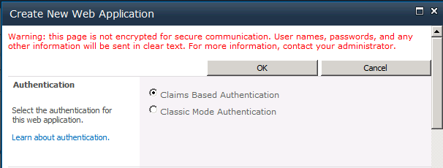

* 1. Scroll down to the **IIS Web Site** section. Select the option to **Create a new IIS web site** and enter a **Name** of **Wingtip Intranet**. Enter a **Port** of **80**. For the **Host Header** setting, add a value of **intranet.wingtip.com**. Add a **Path** value of **c:\inetpub\WingtipIntranet**. When you are done, you entries should look like the ones below.

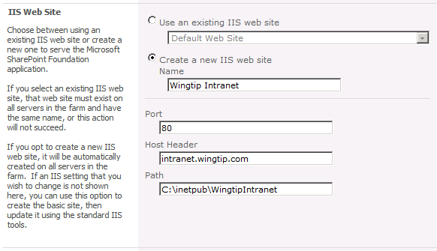

* 1. Scroll down to the **Security Configuration** section and fill it out so it looks like the following screenshot.

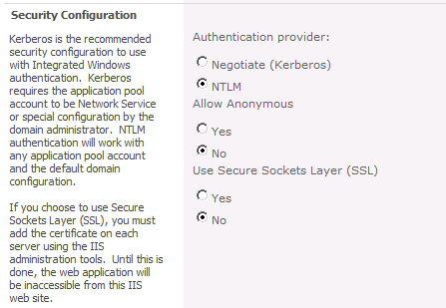

* 1. Scroll down to the Application Pool section. Select the option to **Create new application pool** and enter an **Application pool name** of **SharePoint Default App Pool**. Make sure you configure the identity for the new application pool with the **WINGTIP\SP_WorkerProcess** account as shown in the following screenshot.

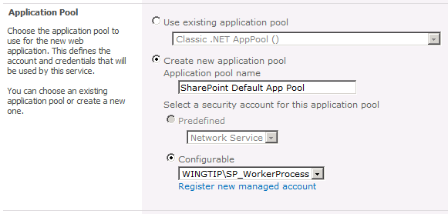

* 1. Scroll down to the **Database Name and Authentication** section. Make sure the Database Server setting has a value of **WingtipServer**. Next, give the content database a descriptive name of **WingtipIntranet_ContentDB**. Leave the authentication settings at the default value of **Windows authentication**.

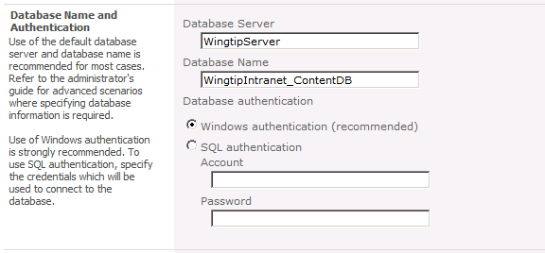

* 1. At this point, you have configured all the necessary information to create the new Web application at [**http://intranet.wingtip.com**](http://bit.ly/9VpDoC). You can leave all other settings with their default values. Scroll down to the bottom of the page and select **No** for the option for the **Customer Experience Improvement Program**. Click **OK** to provision the new Web Application.
  2. After SharePoint Server provisions the new Web application, it displays the following dialog. Click on the blue link with the caption of **Create Site Collection**.
  3. The next page provides input controls for you to enter information about the new site collection. Enter a **Title** of **Wingtip Intranet**. Leave the **URL** with its default setting so that the new site collection is created at the root of the Web application. Select **Team Site** as the site template for the top-level site.

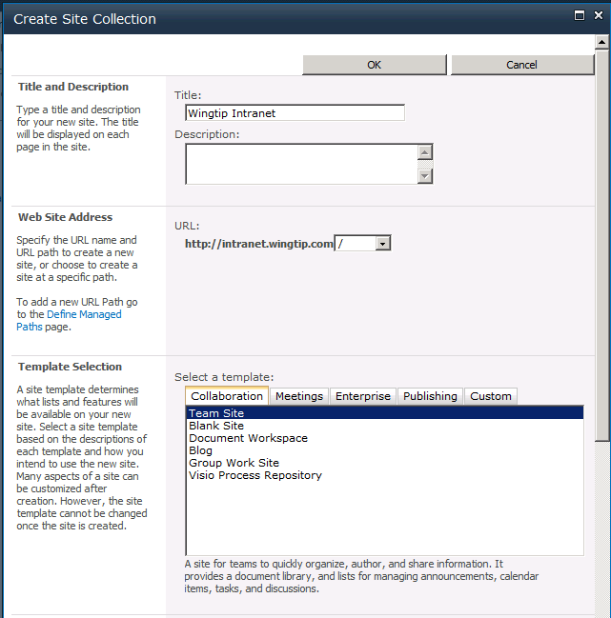

* 1. Configure the **Primary Site Collection Administrator** setting with the user account **WINGTIP\Administrator**.

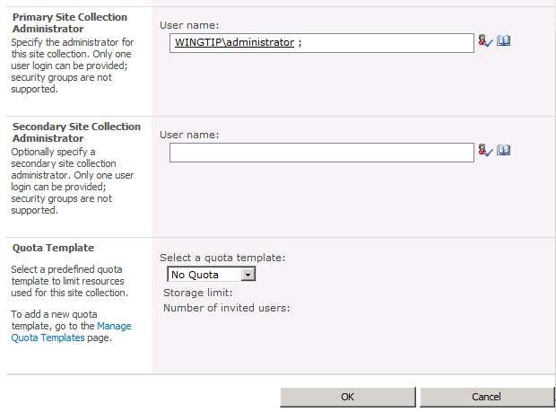

* 1. Click **OK** to begin the provisioning process.
  2. After the new site collection has been created, click the **OK** button.
  3. You will now see a list of SharePoint Web applications.

### Configure Internet Explorer 8 for Testing

To make life easier, there are a few things you can do to configure Internet Explorer when browsing SharePoint 2010 sites.

1. Navigate to the Wingtip Intranet site.
   1. Go to the top-level site by navigating to the URL of [**http://intranet.wingtip.com**](http://www.microsoft.com/downloads/details.aspx). Click OK to dismiss and go back to central admin. You will be prompted for a login and password. Enter **Wingtip\Administrator** and a password of **Password1**. You should be able to see the home page of the site running inside the Web application you just created.

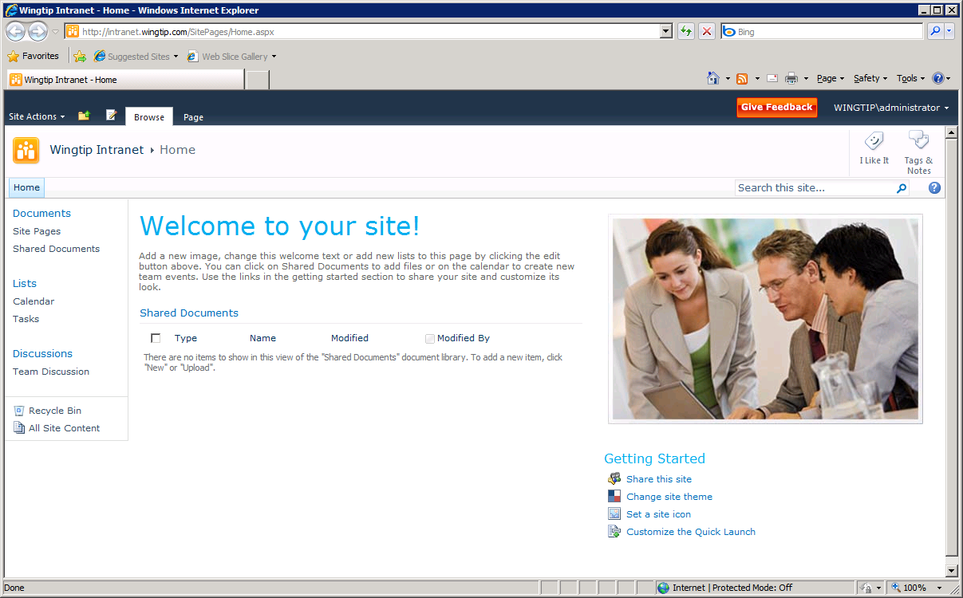

1. Configure Internet Explorer for automatic Windows authentication. The purpose of this step is to eliminate the need to enter a user name and password when you navigate to this site or any other site within the Web application at [**http://intranet.wingtip.com**](http://intranet.wingtip.com).
   1. Inside the Internet Explorer, drop down the **Tools** menu and select **Internet Options**.
   2. In the **General** tab of the **Internet Options** dialog, enter a **Home page** address of [**http://intranet.wingtip.com**](http://www.youtube.com/users/CriticalPathTraining). Click the **Apply** button to save your setting.
   3. Navigate to the **Security** tab of the **Internet Options** dialog. Select the zone named **Local Intranet**. Click the **Sites** button to configure the **Local Intranet** zone.
   4. When you click the Site button in the previous step, the Internet Explorer will display the following dialog. Click on the **Advanced** button
   5. The next dialog allows you to add one or more URLs that will be added to the Local Intranet zone. Add the URL of **http://*.wingtip.com**.
   6. Click **Close** to dismiss the first dialog. Next click **OK** to dismiss the next dialog which should bring you back to the original Internet Options dialog. Click **OK** to save all your changes.
2. Now close the Internet Explorer and then reopen it. You should be able to see the home page of the new Team Site you created at [**http://intranet.wingtip.com**](http://bit.ly/blSbXT) without having to enter any login information.

## Section 5: Install Microsoft Office 2010 Client Applications

In the next step, you will install the 32-bit version of the Microsoft Office 2010 client applications. Be sure to download and install the 32-bit version and not the 64-bit version. The reason for selecting the 32-bit version over the 64-bit version is because the 64-bit version does not include some things you will want in your SharePoint environment, including the SharePoint list Data Sheet view.

Review to the following video for a walkthrough on the following steps: [**http://bit.ly/df0NIJ**](http://bit.ly/bM29wb).

### Install Office 2010 Professional Plus

1. Download the installation software from Microsoft’s download site.

**Note:** You can use the trial version of Office Professional Plus 2010 available from Microsoft ([**http://technet.microsoft.com/en-us/evalcenter/ee390818.aspx**](http://www.microsoft.com/downloads/details.aspx) or [**http://bit.ly/cfrO0P**](http://intranet.wingtip.com)) or you can use a licensed copy you have acquired from an MSDN subscription or within your organization.

* 1. Download **Office Professional Plus 2010** to your host machine in a location where it will be accessible to the VM.
  2. In the VM, navigate to the location of the installer and double click it**.**
  3. Accept the default installation options by clicking the **Install Now** button.
  4. When installation is complete, you will see the following dialog. Click **OK**.

1. Launch Microsoft Word and make sure it starts without problems.
   1. Start Microsoft Word 2010 from the Windows Start menu:  
      **Start » All Programs » Microsoft Office » Microsoft Word 2010**

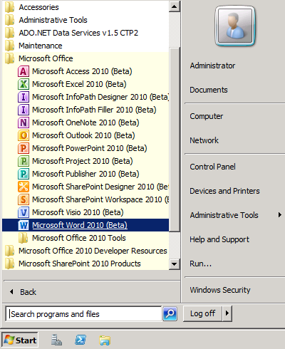

* 1. The first time you launch Microsoft Word 2010, you will see the following dialog. Select **Don’t make changes** and click **OK**.

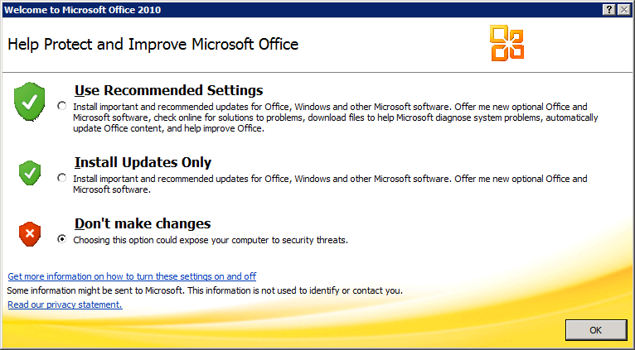

* 1. Close Microsoft Word 2010.

### Install SharePoint Designer 2010

1. Download the 32-bit version of SharePoint Designer from the following URL**:**

[http://www.microsoft.com/downloads/details.aspx?FamilyID=d88a1505-849b-4587-b854-a7054ee28d66](http://msftdbprodsamples.codeplex.com/releases/view/45907?FamilyID=d88a1505-849b-4587-b854-a7054ee28d66) or [http://bit.ly/94poZ4](http://intranet.wingtip.com).

* 1. Click **Download** to get SharePoint Designer 2010.
  2. Once downloaded, run the **SharePointDesigner.exe** file and install SharePoint Designer 2010.

1. Launch SharePoint Designer 2010 and make sure you can connect to the site at [**http://intranet.wingtip.com**](http://bit.ly/9MHYYS).
   1. Start SharePoint Designer 2010 from the Windows Start menu.  
      **Start » All Programs » SharePoint » SharePoint Designer 2010**.
   2. Click the **Open Site** button in the top left-hand section of main work area.

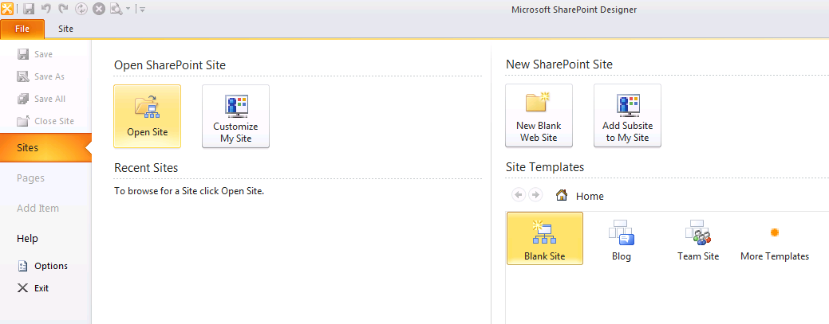

* 1. Open the site at the path of [**http://intranet.wingtip.com**](http://bit.ly/9R2ju8)**.** Note that the Open Site dialog can be a bit confusing because it displays all the folders inside the site. All you need to do is enter an URL of http://intranet.wingtip.com in the **Site name** textbox and then click the **Open** button to open the site in the SharePoint Designer 2010.
  2. Verify that the site at [**http://intranet.wingtip.com**](http://www.microsoft.com/downloads/details.aspx) opened correctly in the SharePoint Designer 2010 and that you can navigate around the various types of SharePoint objects.
  3. Close SharePoint Designer 2010.

### Install Visio 2010

1. Download Visio 2010 from the trial download link provided by Microsoft ([**http://technet.microsoft.com/en-us/evalcenter/ee390821.aspx**](http://bit.ly/a0WYdZ) or [**http://bit.ly/9MHYYS**](http://www.microsoft.com/downloads/details.aspx)) or you can use a licensed copy you have acquired from an MSDN subscription or within your organization.
2. When prompted, accept all the default options.

### Configure Office 2010 Trust Settings

1. When installing Office 2010 on the same machine as SharePoint Server 2010 you need to do one more thing to get the Office clients to save files to the server. You need to disable the Protected View in Office.
   1. Launch **Word 2010**: **Start » Microsoft Office » Microsoft Word 2010**.
   2. Using the ribbon select **File » Options**.
   3. Select the **Trust Center** from the list of options and click the **Trust Center Settings** button.
   4. Select the **Protected View** and uncheck all the **Protected View** options on this dialog, leaving only the **Enable Data Execution Prevention** **mode** checked.

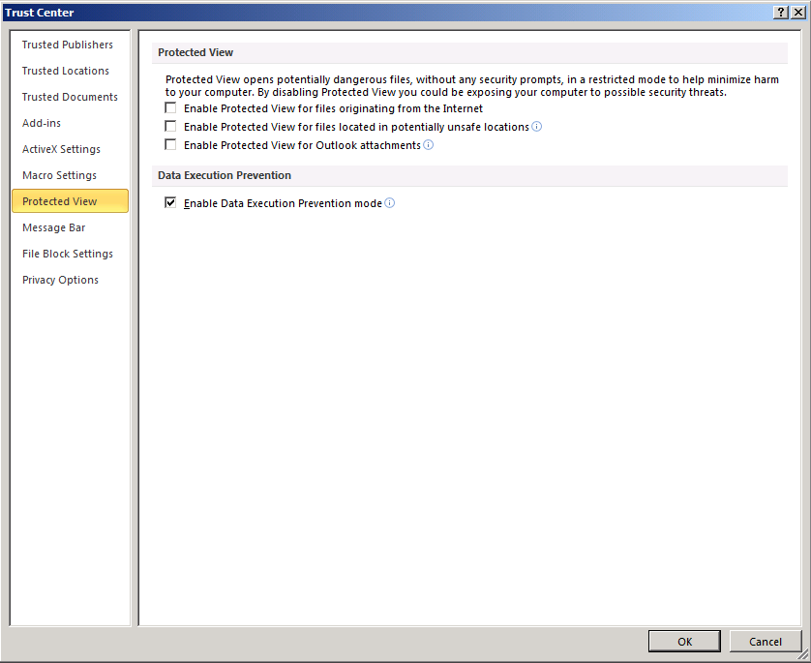

* 1. Click **OK** multiple times to close the dialogs and exit out of Word 2010.

## Section 6: Install Visual Studio 2010

In this step you will install the Visual Studio 2010 which includes the SharePoint Tools.

Review to the following video for a walkthrough on the following steps: [**http://bit.ly/aDT3hj**](http://intranet.wingtip.com).

1. Download the ISO file for **Microsoft Visual Studio 2010 Ultimate**.
   1. Download the Visual Studio 2010 Ultimate trial from the following URL, or use your own licensed copy of Visual Studio 2010 Ultimate: [**http://www.microsoft.com/downloads/details.aspx?familyid=06A32B1C-80E9-41DF-BA0C-79D56CB823F7**](http://bit.ly/a9Vo68?familyid=06A32B1C-80E9-41DF-BA0C-79D56CB823F7) or [**http://bit.ly/bErhyI**](http://bit.ly/a5prrU).
   2. Extract the downloaded files and attach the extracted *.ISO to the VM.
2. Install **Microsoft Visual Studio 2010**:
   1. Run **setup.exe**.
   2. Click on the link to **Install Microsoft Visual Studio 2010**.
   3. Click **Next** to move past this dialog.
   4. Select the option **I have read and accept the license terms** and click **Next**.
   5. On the **Select features to install** dialog, select the **Custom** option and click **Next**.

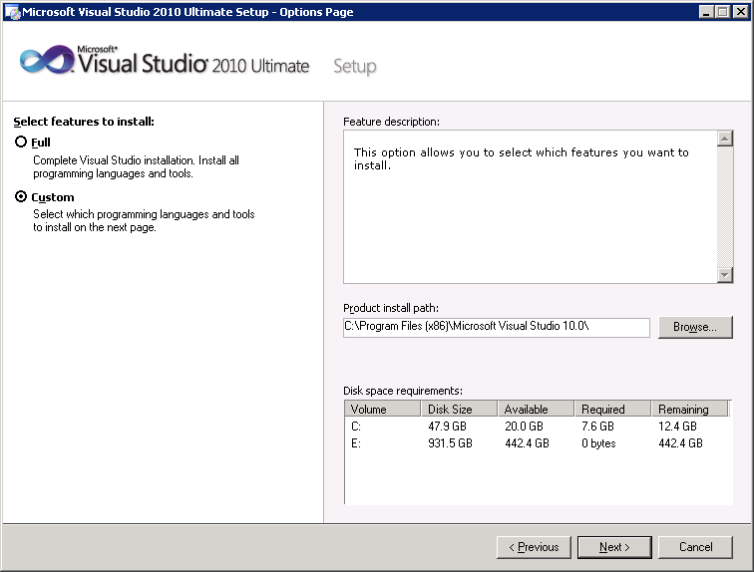

* 1. On the next dialog where you select the features to install, there is only one thing you will change from the default settings. Unselect the checkboxes for **Visual F#**, **Visual C++**, **Graphics Library**, **Dotfuscator Software Services – Community** and **Microsoft SQL Server 2008 Express Service**. You are actually free to install everything except SQL Express; the things you removed are not necessary for SharePoint development.

Unselecting the SQL Express option is required because the VM already has an installation of SQL Server 2008 R2 Enterprise. If you attempt to install the SQL Server 2008 Express Service, it could cause a failure in the Visual Studio 2010 installation process. Click **Install** to begin the installation process.

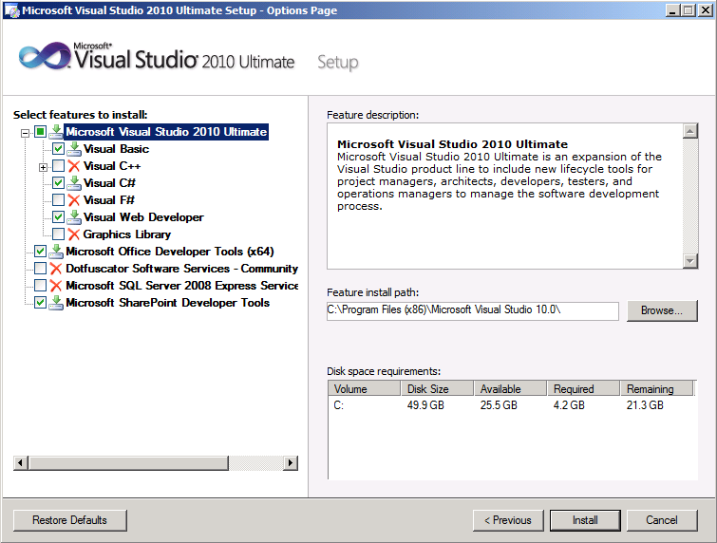

* 1. In the first phase of Visual Studio 2010 installation, the installer program installs a beta version of the .NET Framework 4.0. Afterwards, the installer program asks you to reboot your computer. Click the **Restart** button to reboot the VM.
  2. After the VM has rebooted, log in as **WINGTIP\Administrator**. Once you are logged in, the Visual Studio 2010 installation will automatically resume. This second phase of the installation process will take between 10 and 20 minutes to complete. When the installation process is complete, you should see the **Success** dialog. Click **Finish** to end the installation process.

1. Install the Visual Studio 2010 SDK.
   1. Go to the following download page for the SDK: [**http://www.microsoft.com/downloads/details.aspx?FamilyID=47305cf4-2bea-43c0-91cd-1b853602dcc5**](http://intranet.wingtip.com?FamilyID=47305cf4-2bea-43c0-91cd-1b853602dcc5?FamilyID=47305cf4-2bea-43c0-91cd-1b853602dcc5) or [**http://bit.ly/ckFjiN**](http://technet.microsoft.com/en-us/evalcenter/ee390821.aspx).
   2. Click the download link to download the installation file named **VsSDK_sfx.exe**.
   3. On the VM, double-click on **VsSDK_sfx.exe** to begin installation of the SDK. When you get to the **Welcome to Setup** screen, click **Next**.

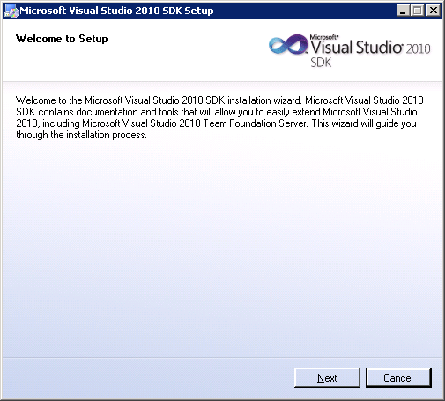

* 1. Accept the terms of the licensing agreement and clock **Next**.
  2. On the **Destination Folder** page, leave the folder default setting and click **Next** to start the SDK installation.
  3. When you see the **Setup Complete** dialog, click **Exit** to finish the installation.

1. Test connecting to the local farm using the Visual Studio 2010 SharePoint Tools
   1. Launch Visual Studio 2010 from the Windows **Start** menu:  
      **Start » All Programs » Microsoft Visual Studio 2010 » Microsoft Visual Studio 2010 - ENU**

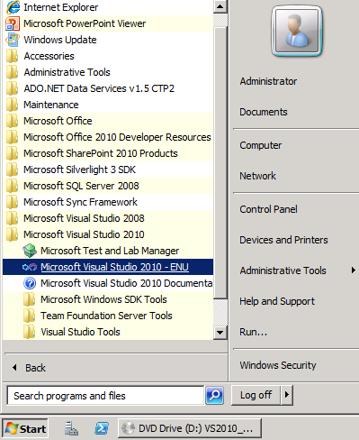

* 1. The first time you launch Visual Studio 2010, it will display the following dialog to **Choose your default environment settings**. Select **General Developer Settings** and then click the **Start Visual Studio** button.

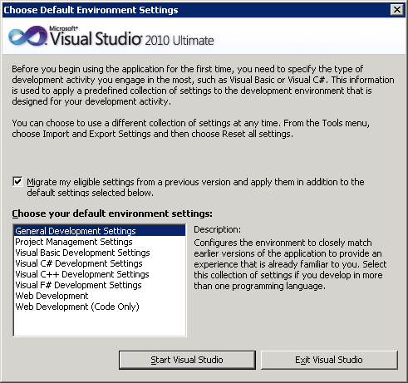

* 1. When Visual Studio starts up, locate the Server Explorer window on the left-hand side of the main window of Visual Studio 2010. If you do not see the Server Explorer, drop down the **View** menu and select the **Server Explorer** menu command.

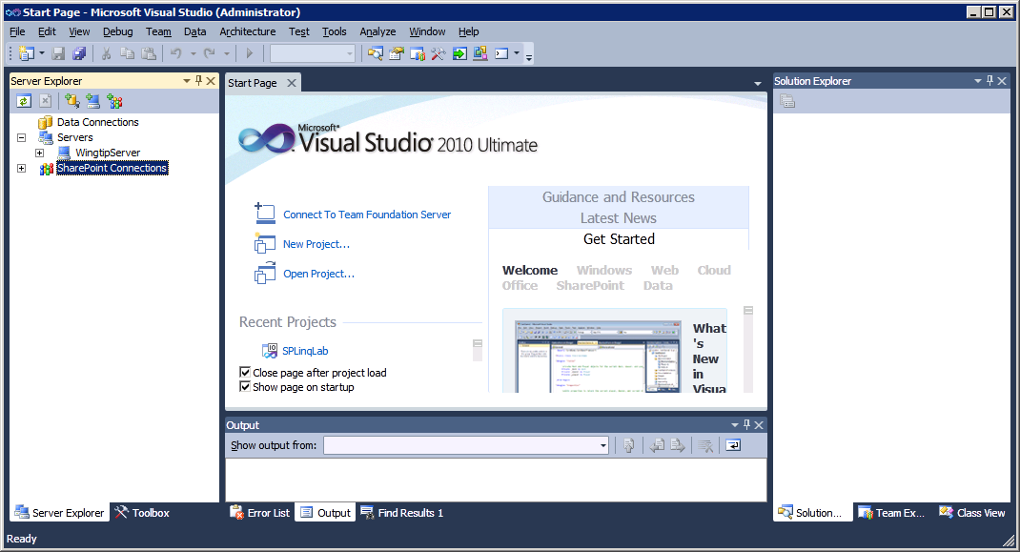

* 1. Locate the right-most button on the toolbar of the Server Explorer windows and click it to add a new SharePoint connection.

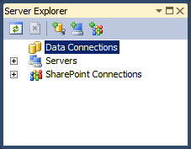

* 1. In the Add SharePoint Connection dialog, enter the URL [**http://intranet.wingtip.com**](http://bit.ly/99uUgn) and click **OK**.

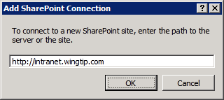

* 1. Verify you can see and drop down nodes within the new connection.

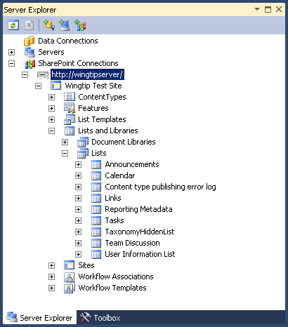

## Appendix A: Download Windows Server 2008 R2 Evaluation VM

In this step you will download Microsoft’s free evaluation VM for Windows Server 2008 R2 Enterprise (Full Edition). This VM will serve as a starting point for building out a SharePoint development environment.

1. Download the trial VHD for the **Windows Server 2008 R2 Enterprise Evaluation** from the URL below. Make sure you download the **Full Edition** instead of the **Server Core** edition.

[http://www.microsoft.com/downloads/details.aspx?FamilyId=9040a4be-c3cf-44a5-9052-a70314452305](http://intranet.wingtip.com?FamilyId=9040a4be-c3cf-44a5-9052-a70314452305?FamilyId=9040a4be-c3cf-44a5-9052-a70314452305) or [http://bit.ly/bM29wb](http://bit.ly/9DyhlN).

After you have completed the download, you should have an EXE file on your local hard drive named **Windows Server 2008 R2 Enterprise Evaluation (Full Edition).exe**

1. Extract VM image from **Windows Server 2008 R2 Enterprise Evaluation (Full Edition).exe**
   1. Double click the EXE for to begin the extraction. This will extract the VHD file named **Windows Server 2008 R2 Enterprise Evaluation (Full Edition).vhd**.
   2. Rename the VHD file to **WingtipServer.vhd**
   3. Move or copy **WingtipServer.vhd** to the location on a local hard drive from which the Hyper-V service will run it.
2. Use The Hyper-V Manager to create a new Virtual Machine to run **WingtipServer.vhd**
   1. Launch the Hyper-V Manager from Administrative Tools
   2. Start the New Virtual Machine Wizard
   3. When the wizard prompts you for the machine name, enter **WingtipServer**.
   4. When the wizard prompts you to assign memory, use the following as a guideline:
      1. If your host machine has 6GB of RAM, enter a **Memory** value of **4092MB** (4GB)
      2. If your host machine has 8GB of RAM, enter a **Memory** value of **6144MB** (6GB)
      3. If your host machine has 12GB of RAM, enter a **Memory** value of **8192MB** (8GB)
   5. When the wizard prompts you for a network connection, select **HostLanCard**
   6. When the wizard prompts you to **Connect Virtual Hard Disk**, choose **Use an existing virtual hard drive** and browse to select **WingtipServer.vhd**.

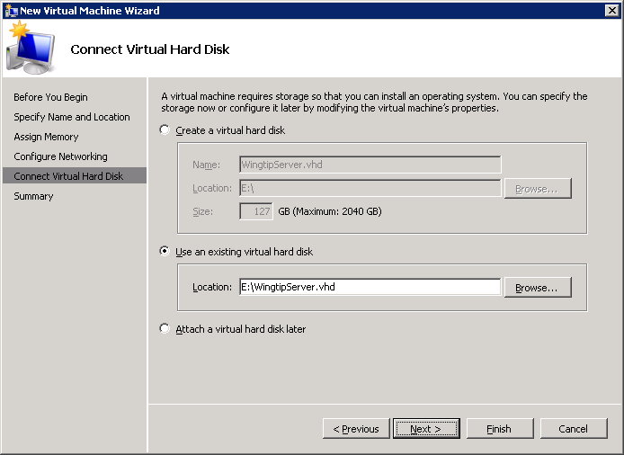

* 1. When you complete the New Virtual Machine Wizard as shown below, Click **Finish**.

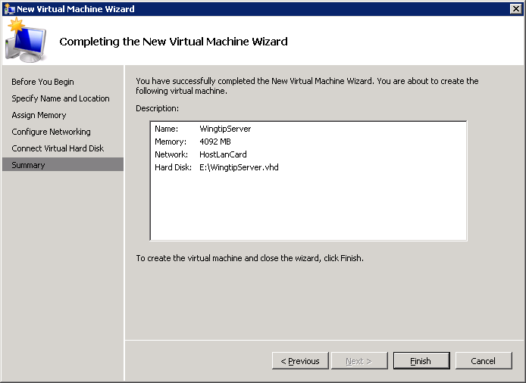

1. Configure and start the new VM
   1. Before starting the VM, inspect its settings page using Hyper-V Manager
   2. By default, the number of processors is set to 1. If your hardware supports multiple processors, increase the number of processors to the maximum number allowed.
   3. Now start the VM
   4. Connect to the VM through the Hyper-V console and wait for the boot process to complete.
2. First, change the Administrator password and disable the requirement to change it.
   1. Login with User name of **Administrator** and password of **Pass@word1**. Note that this is the password that Microsoft used to build the trial VM.
   2. Once you have logged in for the first time, the virtual machine may or may not prompt you to restart it depending on your hardware setup. If prompted, go ahead and restart the VM. At this point the operating system is making some internal virtual hardware changes and needs to reboot in order to apply them.
   3. After you log in, Windows Server displays the **Initial Configuration Tasks** window. Click the check box with the caption **Do not show this window at logon** and then click the **Close** button. After you close this window, Windows Server will display the **Server Manager**. If the Server Manager is not open, launch it from the Windows Start menu using **Start “ Administrative Tools “ Server Manager**.
   4. In this step you will configure the Administrator account so that its password does not expire. Inside the **Configuration** node of the Server Manager, navigate the **Users** folder inside the **Local Users and Groups** node (as shown in the following screenshot) and locate the local **Administrator** account. Right-click on the **Administrator** account and click **Properties**.



* 1. In the **Administrator Properties** dialog, unselect the option for **User must change password at next logon** and select the option for **Password never expires**.

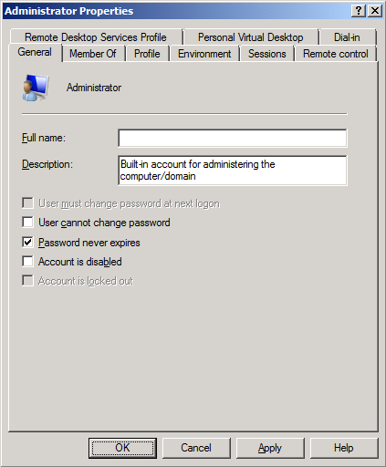

* 1. Change the administrator password from **pass@word1** to **Password1**.

1. Now rename the computer name of the VM. In the Server Manager, navigate to the top-level node to display the **Server Summary** page. Click **Change System Properties**.



* 1. On the **Computer Name** tab of the System Properties dialog, click the **Change** button.



* 1. Enter a new computer name of **WingtipServer** and click OK. Note there is no need to change the Workgroup because later you are going to create a new domain.



* 1. After changing the computer name you will be prompted to restart the VM. Choose **OK** to restart. After the VM has restarted, log in again using the same credentials as before.
  2. Rejoin the instructions in **Step 2: Install and Configure Windows Server 2008 R2** and jump to step 6

## Appendix B: Create the Sample Adventure Works Databases

These steps will lead you through installing the sample Adventure Works Databases. These databases will be helpful in testing SharePoint 2010

1. Get the installation file to to install Adventure Works Databases
   1. Go to the download page on CodePlex at the following URL.

[http://msftdbprodsamples.codeplex.com/releases/view/45907](http://bit.ly/bErhyI) or [http://bit.ly/blSbXT](http://wingtipserver:9999/_admin/adminconfigintro.aspx).

* 1. Download the latest posted version.

1. Begin the installation by double clicking the *.EXE to install the Adventure Works databases:
2. When prompted to select which databases to install, accept all defaults which installs everything and has a few manual deployments steps post install.
3. Once the installer completes you will need to build Adventure Works Cube using SQL Server Business Intelligence Development Studio:
   1. Launch SQL Server BI Development Studio by using the shortcut in the Windows start menu: **Start » All Programs » Microsoft SQL Server 2008 R2 » SQL Server Business Intelligence Development Studio**.

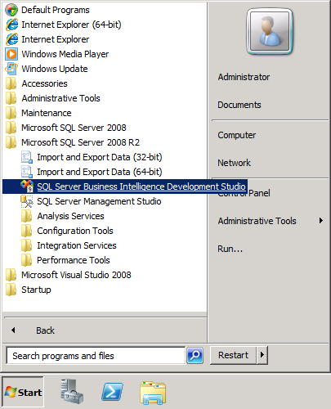

* 1. From within Business Intelligence Development Studio, you the **File** » **Open Project** menu command to open the project at the following location.

C:\Program Files\Microsoft SQL Server\100\Tools\Samples\AdventureWorks 2008R2 Analysis Services Project\enterprise\Adventure Works.sln

* 1. With the project open, right click on **Adventure Works DW 2008** project node and execute the **Deploy** command. The deployment process will take a minute or two to build out the Adventure Works data warehouse cube. You will receive a deployment success message after the deployment process completes.

## Appendix C: Install SharePoint Developer Utilities and SDKs

These utilities will be required when working through the lab exercises of SharePoint developer courses offered by Critical Path Training,

1. Install the **SharePoint 2010 SDK**:

[http://www.microsoft.com/downloads/details.aspx?familyid=F0C9DAF3-4C54-45ED-9BDE-7B4D83A8F26F](http://technet.microsoft.com/en-us/evalcenter/ee388573.aspx?familyid=F0C9DAF3-4C54-45ED-9BDE-7B4D83A8F26F) or [http://bit.ly/dcvJ6A](http://intranet.wingtip.com).

1. Install the **OpenXML SDK 2.0**:

[http://www.microsoft.com/downloads/details.aspx?FamilyId=C6E744E5-36E9-45F5-8D8C-331DF206E0D0](http://bit.ly/bcZ4S7?FamilyId=C6E744E5-36E9-45F5-8D8C-331DF206E0D0) or [http://bit.ly/a5prrU](http://www.microsoft.com/downloads/details.aspx).

1. Install the **Windows Identity Framework (WIF) SDK**:

[http://www.microsoft.com/downloads/details.aspx?FamilyID=c148b2df-c7af-46bb-9162-2c9422208504](http://intranet.wingtip.com?FamilyID=c148b2df-c7af-46bb-9162-2c9422208504?FamilyID=c148b2df-c7af-46bb-9162-2c9422208504) or [http://bit.ly/99uUgn](http://bit.ly/a9Vo68).

## Appendix D: Install the Office Web Applications

In this section you will install the Office Web Application so that you will be able to edit Microsoft Word documents and PowerPoint presentations through the browser. These components are not installed with SharePoint Server 2010. Instead, they come as a separate installation and they can be installed in SharePoint 2010 farms running either SharePoint Server 2010 or just SharePoint Foundation 2010.

There is no trial install for the Office Web Applications, instead you must have a MSDN license or volume license.

For more information about how to acquire the Office Web Applications, refer to this link: [http://technet.microsoft.com/en-us/office/ee815687.aspx](http://www.microsoft.com/downloads/details.aspx) or [http://bit.ly/9VpDoC](http://bit.ly/dcvJ6A).

1. Download the Office Web Applications installation files and make them available to the VM.
2. Begin the setup program by double-clicking **setup.exe**. When prompted, enter your product key.
3. In the Welcome dialog, click **Next**.
4. In the Licensing dialog, accept the terms of the licensing agreement and click **Continue**.
5. In the Choose a file location dialog, accept default values and click **Install Now**.
6. In the Run Confdiguration Wizard dialog, accept the default values and click close.
7. A dialog asks you if it is OK to stop the IIS service. Click **Yes**.
8. On the next dialog shown below, click **Next**.
9. On the **Configuration Successful** dialog, click **Finish**.

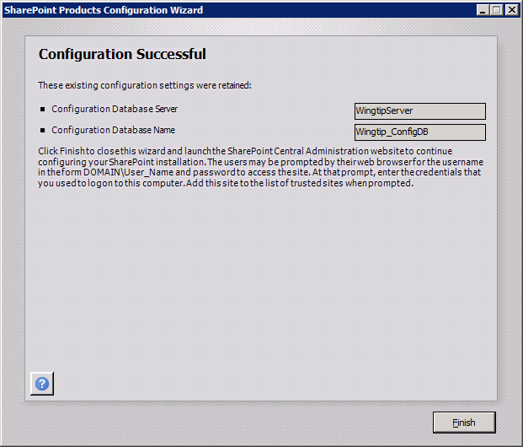

1. You should now be directed to the page shown below. Click the **Start the Wizard** button.

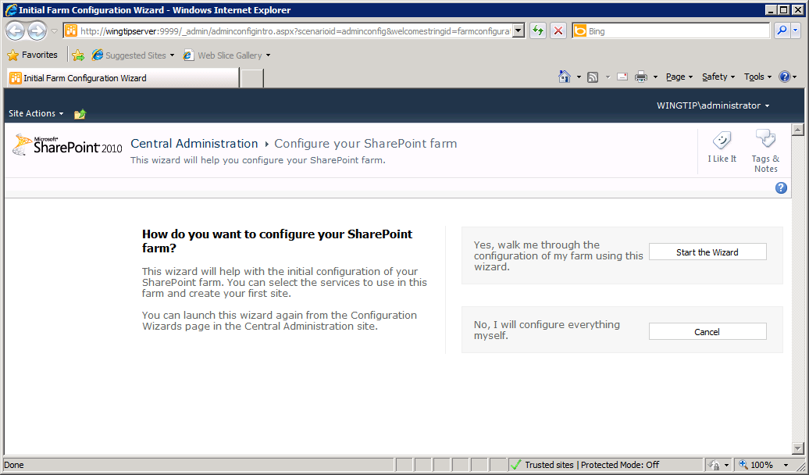

1. When you start the wizard, you will be taken to the page shown below.

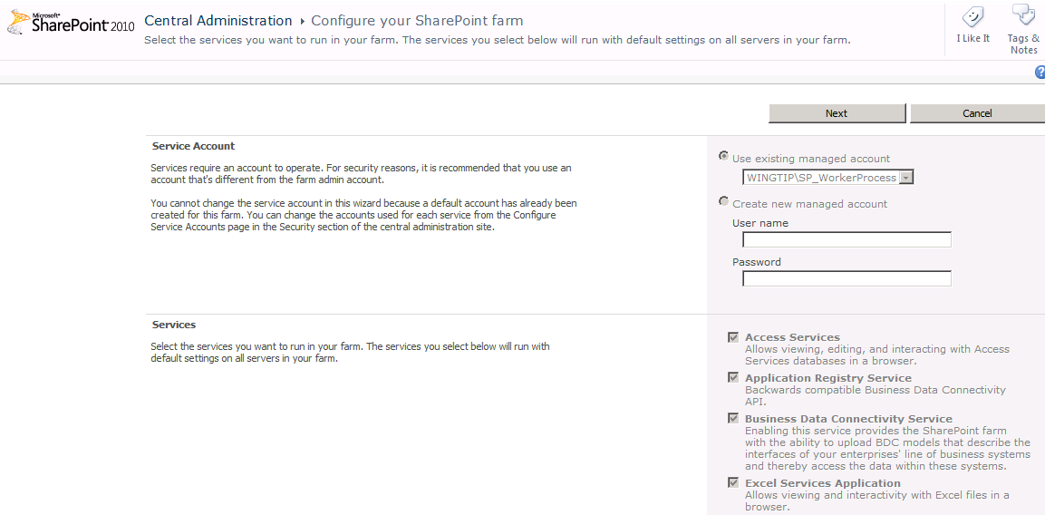

1. You should see in this page that all the SharePoint Server service application have already be created. The two application services that are not grey out in the wizard are PowerPoint Service Application and Word Viewing Service. Note that there is nothing you need to do on this page except for clicking the **Next** button. Do that now.

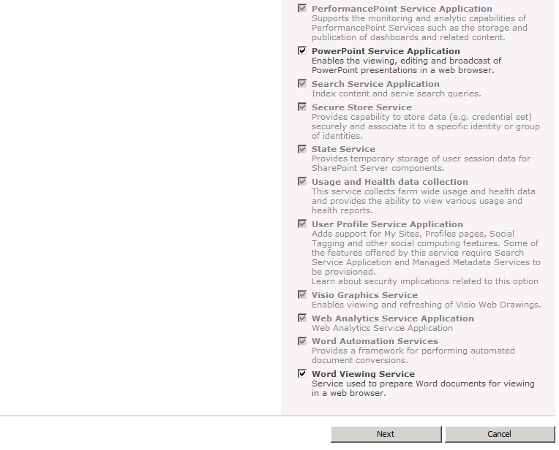

1. The next page asks you if you want create a new site collection. Click **Skip**.